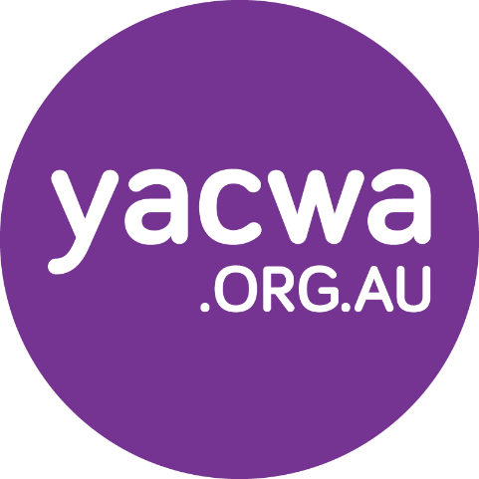

Young People’s Priorities for Action: Mental Health, Alcohol and Other Drugs Youth Engagements

Summary Report: November 2021
Prepared for the Mental Health Commission of Western Australia
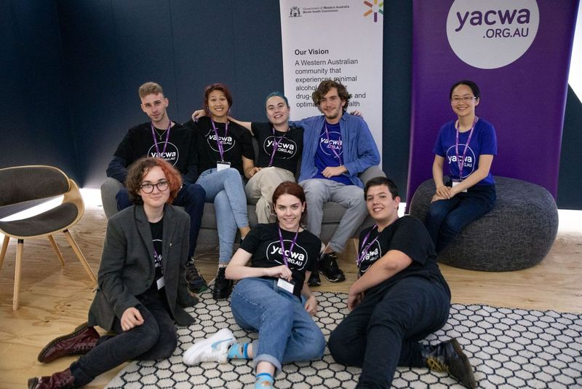

Acknowledgment of Country
The Youth Affairs Council of Western Australia acknowledges the traditional custodians of country on which this report was based, the Wadjuk people of the Noongar Nation, and their continuing connection to land, sea and community. We pay our respect to their Elders both past and present, as well as acknowledge and celebrate the ongoing contributions of Aboriginal young people in our communities.

About the Youth Affairs Council of Western Australia (YACWA)
The Youth Affairs Council of Western Australia (YACWA) is the peak non-government youth organisation in Western Australia. YACWA operates primarily as a human rights organisation that seeks to address the exclusion of young people in a rapidly changing society.
Our vision for Western Australia is one that celebrates and engages young people in all aspects of the community. Our role is to strengthen the trust, cooperation, collaboration, professionalism and voice of the non-government youth service sector to better serve the young people of Western Australia.
YACWA is widely acknowledged as a leader in the field of current youth participation best practice. This reputation has a national profile and is supported by academic research, proven training and project management and, most importantly, extensive engagement with children and young people. YACWA strongly believes that children and young people are the ‘experts in their own experiences and wellbeing’ and we are dedicated to ensuring their equal access to participation in community decision-making processes.

Connection and Wellbeing Australia (CAWA)
Large parts of this project were led by Connection and Wellbeing Australia (CAWA). CAWA focus on providing training and support to work towards our vision of a suicide safer, mentally healthy and more inclusive community.
CAWA’s believes in a suicide safer community where all individuals feel confident and skilled to support people with thoughts of suicide and to ask for support for themselves. CAWA create safe spaces the empower community members to talk openly about suicide, mental health and wellbeing

Contents
Executive Summary 5
Project Background 6
Engagement Process 10
The Youth Steering Group 11
Recruitment 11
Support 11
Essential Principles of Youth Service Design 12
Metropolitan Summit Findings and Insights 14
Summary of Engagement 14
Event Design and Safety 15
Group 1: Peer Workers 16
Group 2: FDV, AOD and Mental Health 19
Group 3: Workforce/workplace 21
Group 4: School and TAFE 24
Regional Summit Findings and Insights 27
Summary of Engagement 27
Group 1: Peer Workers 28
Group 2: Lifespan 30
Group 3: Stigma & Discrimination 32
Additional Engagements Findings and Insights 33
Summary of Engagement 33
Engagement 1: Regional Young People (Pilbara) 34
Engagement 2: Public Health Campaigns (Youth Steering Group) 37
Engagement 3: LGBTIQA+/TGD 38
Engagement 4: Culturally and Linguistically Diverse Young People 42
Engagement 5: Family carers 43
Engagement 6: Eating Disorders 45
Engagement 7: First Nations 47
Engagement 8: Regional Young People (Goldfields) 50
Engagement 9: Young People with Disability 52
Evaluation and next steps 53
Youth Steering Group Reflections 53
Voices Requiring Further Engagement 55
Appendix A: Engagement Strategy 56
Appendix B: Metropolitan summit run sheet 62
Appendix C: Facilitators guide 66
Appendix D: Regional summit run sheet 73

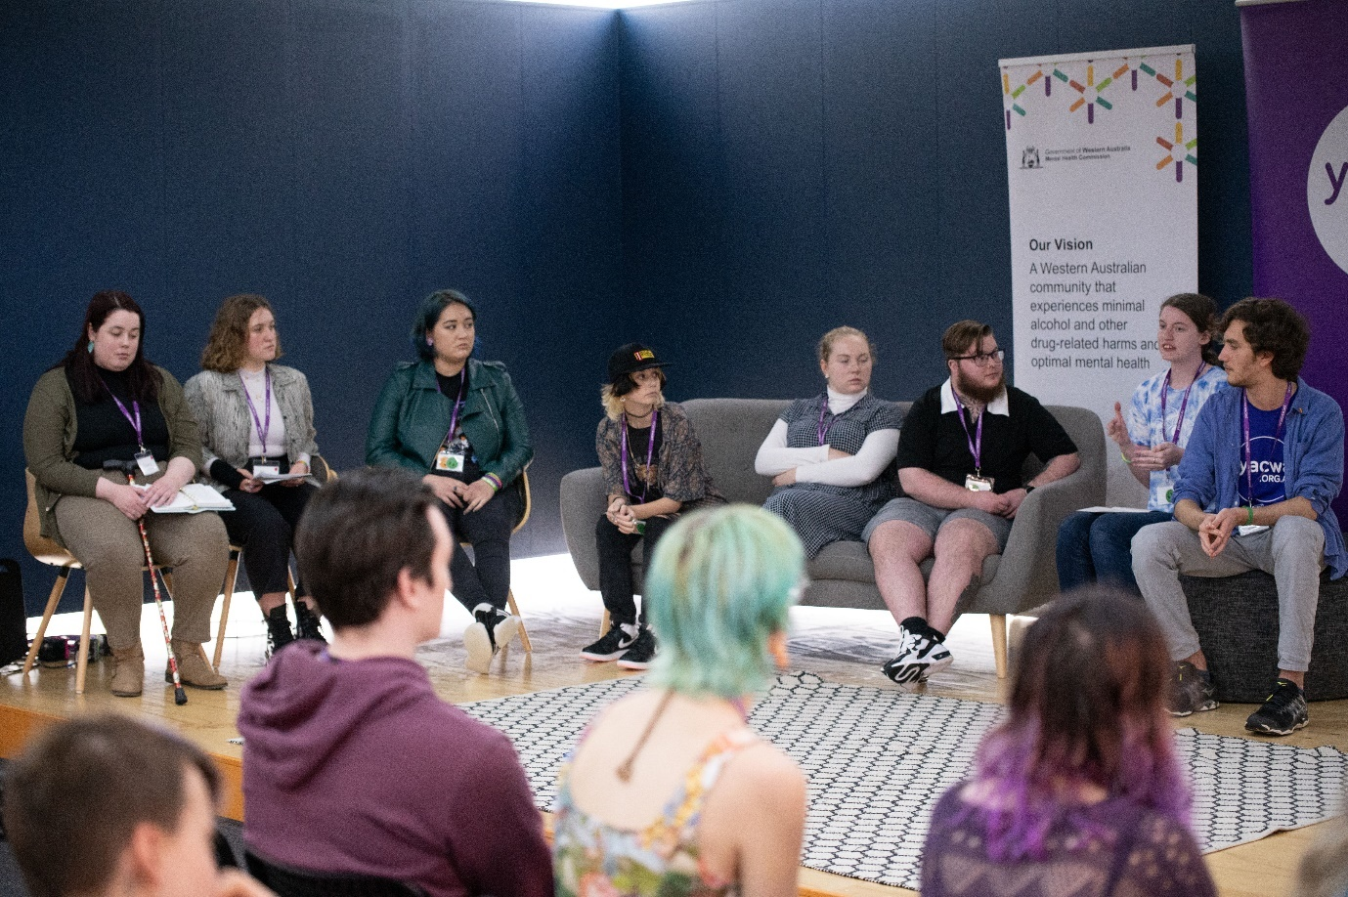

Executive Summary
In June 2021, YACWA was contracted by the Mental Health Commission to develop and deliver a youth engagement project, working with both young people and key State Government stakeholders, to inform the implementation of the Young People’s Mental Health and Alcohol and Other Drug Use: Priorities for Action 2020-2025 (the YPPA). YACWA then subcontracted Connection and Wellbeing Australia (CAWA) to lead the engagement with young people.
The YPPA was developed in consultation with 162 young people across surveys, group forums, and service-led discussions in 2020, and released in December of that year. The YPPA provided direction and outlined key priorities to improve youth mental health and alcohol and other drug services and community contexts in Western Australia.
The intent of this engagement project was to:
- Ensure young people’s lived experiences and knowledge of the mental health, alcohol and other drug services systems, including their ideas for innovation and change, were able to guide the implementation of the YPPA.
- Build relationships and connections among the MHC and cross-government Senior Officers Working Group (SOWG) responsible for the YPPA’s implementation with young people with a diversity of lived experiences and backgrounds across the mental health and alcohol and other drugs sectors.
- Support ongoing connections between young people, the MHC, and the Senior Officers Working Group (SOWG), that will lead to long-term participation of young people in the implementation of mental health and alcohol and other drug planning activities.
In order to complete this work, YACWA recruited 10 young people with a diversity of lived experience of mental health, alcohol and/or other drug use, into paid roles to form a Youth Steering Group (YSG) that co-designed and co-delivered the project from beginning to end. The YSG formed the defining and guiding voice for this engagement that, despite working within the parameters set by YACWA’s contract with the MHC, greatly influenced the approach and nature of the project through their expertise and wisdom.
The MHC provided to the YSG a list of priorities from the YPPA that had been identified as key priorities for progression in the immediate or near-future from cross-government engagement and consultation.
The YSG designed all aspects of the engagement approach of the project, including the nature of facilitation, creating the culture and tone of all events (set by both young people and government stakeholders), and how young people from diverse experiences would be supported and encouraged to participate.
In order to appropriately engage young people in the YPPA’s implementation, the YSG led the following activities:
- Design and delivery of a two-day youth mental health and alcohol and other drugs summit in the Perth Metropolitan area, focused on co-designing priorities identified by the MHC. This was attended by 31 young delegates and stakeholders from the SOWG.
- Design and delivery of a one-day online youth mental health and alcohol and other drugs summit for young people from regional and remote area. This was attended by 12 young people.
- Identifying and supporting up to 10 additional youth engagement activities to speak with young people from diverse backgrounds on priorities from the YPPA that impact unique cohorts of young people. These included individual conversations, online surveys, and small focus groups/workshops.
The project had significant learnings and positive community outcomes that rippled beyond the scope of the engagement outcomes alone. In particular, the skills and capacity-building work undertaken with the YSG was profound and many individuals reported an increase in their own positive wellbeing, employment skills, and understanding of navigating the mental health and alcohol and other drug sectors.
Throughout the document, four key themes emerged to guide the implementation of all priorities in the YPPA:
- Youth participation: Ongoing co-design and partnerships with young people is critical to success. Community consultation is not sufficient, and young people should be active decision-makers and empowered to shape solutions.

- Community partnerships: Effectively supporting the needs of diverse young people requires meaningful partnerships with existing community organisations and leaders. Diverse communities must be supported and empowered in the process, and not just be ‘recipients’ of government services.

- Place-based approaches: Place-based approaches should be prioritised and resourced to ensure services and projects integrate with communities. This includes within commissioning cycles.

- Community expertise: Marginalised communities were seen as the experts in their own affairs and should be supported to make decisions around their wellbeing. New services and approaches should undertake extensive mapping and community consultation.

Project Background
The Youth Affairs Council of Western Australia (YACWA) is the peak non-government youth organisation in Western Australia. We operate primarily as a human rights organisation that seeks to address the exclusion of young people in a rapidly changing society.
YACWA has a long history of consulting with young people and is acutely aware of key issues impacting on young people’s mental health issues and alcohol and other drug (AOD) use. Several reports and previous consultations by YACWA, other agencies and researchers in the last five years have brought to light key challenges for young people regarding accessing services that meet their needs.
Priorities from the YPPA
Following internal and cross-departmental consultation, the MHC provided a list of identified priorities they sought guidance and engagement with young people on from the YPPA.
The identified list spanned many discrete and significant projects, however had significant overlaps in terms of the populations they intended to support, the intended level of intervention (from prevention to crisis support), and their community engagement (including actions to establish new services as well as to strengthen the mental health, alcohol and other drug workforce)—see Table 1.
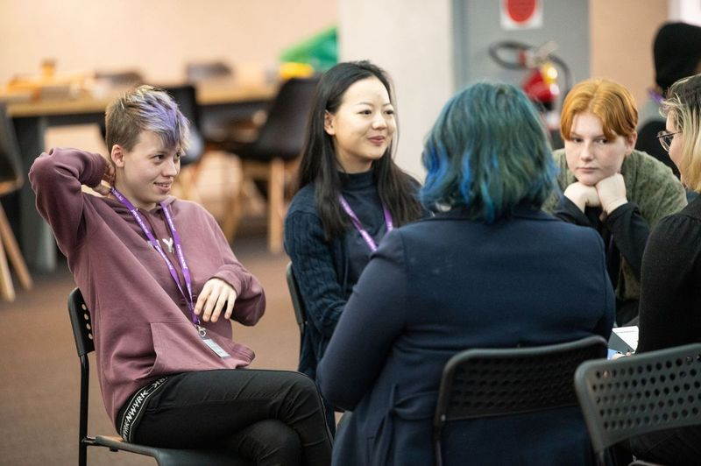
Table 1: YPPA actions identified for young people's input
# | Action
1 | Young people working in the mental health and AOD sector - Develop and promote pathways to encourage young people to work in the mental health and AOD sector, including in prevention and peer work.
2 | Peer workers - Establish system navigation/youth workers and/or youth mentors in emergency departments to support people and smooth transition to community system.
3 | Specific training regarding supporting children and young people - Develop and provide relevant training in supporting and treating children and young people with mental health and AOD issues (e.g. school nurses, GPs, Mental Health Co Response, Emergency Department staff etc).
4 | Culturally secure services - Invest in Aboriginal Community-Controlled Health Services (ACCHS) Social and Emotional Wellbeing programs, developed and led by Aboriginal people and their communities, across all regions of the state.
5 | Expanded state-wide campaigns and related community action in order to:  - Reduce alcohol related harm.  - Minimise the risk of harms relating to drug use.  - Raise awareness of social and emotional wellbeing and the harms associated with AOD use among young Aboriginal people, their families and communities, such as through the Strong Mind, Strong Spirit metropolitan project.
7 | Peer workers - Fund youth peer support programs for LGBTQIA+ young people, young people from refugee and/or migrant backgrounds, Aboriginal young people, and young people living with disability.
8 | Diversity in the workforce - Review recruitment strategies to ensure the attraction and retention of a diverse workforce, including workers from Aboriginal, CaLD, and LGBTQIA+ communities.
9 | Mentally healthy workplaces - Implement the Thrive at Work program across Western Australian industry.
10 | Prevention and promotion within CaLD communities - Identify new distribution channels in the CaLD community, for prevention and promotion materials.
11 | Evidence-based prevention activities in schools - Promote the following existing evidence-based prevention activities within schools:  - Response to Suicide and Self Harm in Schools Program  - School Drug Education Road Aware (SDERA)  - Aussie Optimism  - Teen Mental Health First Aid (MHFA) or other evidence based mental health literacy programs.
12 | AOD transition support workers - Expand youth after hours, outreach and transitional AOD treatment and support services, supporting young people to transition between services.
13 | Integrated family and domestic violence (FDV) and mental health and AOD services - Strengthen FDV services through integrating, co-locating or embedding mental health and AOD workers
14 | Co-occurring mental health and AOD:  - Progressively review all relevant existing models of service and procurement processes so that co-occurring mental health and AOD issues are addressed by a single service or a consortium of services, or effective pathways between different services are established.  - Adopt processes and guidelines for addressing co-occurring mental health and AOD issues in an integrated way, learning from those that have been established and applied in other States and Territories.
15 | Dedicated youth mental health stream:  Continue to work towards establishing a dedicated youth mental health stream for those aged 16 to 24 years in metropolitan and regional WA, including community treatment and inpatient services for people with complex, severe and persistent mental health issues, and building upon services currently working well (such as the community services: Youth Axis, YouthLink and YouthReach South and YCATT).
16 | Forensic services for young people:  Develop a child, adolescent, and youth forensic outreach service for those at risk of, or with a history of offending.
In addition to the above priorities from the YPPA, the MHC identified additional points of engagement they sought feedback and direction on from several State Government agencies with relevance to the YPPA and youth mental health, alcohol and other drug services—see Table 2.

Table 2: Additional points of engagement for young people's input
# | Action
15 | The Department of Health (DoH) would like the young people engaged as part of the YPPA youth engagement activities to focus on providing input into how health services (particularly mental health/AOD) are inclusive and responsive to people from the LGBTQIA+ priority group. In particular, it would be useful to seek their input regarding what sort of staff training would be helpful, and ways services can be more inclusive. This aligns to various YPPA Top Priorities as well as various election commitments DoH have been tasked with
16 | The Department of Local Government, Sport and Cultural Industries would like young people to provide advice regarding how stigma, discrimination and racism can be addressed (relates to 1.8, 1.9, 4.12, 4.13).
17 | The Department of Local Government, Sport and Cultural Industries would like young people to provide advice on culturally secure practices, in particular, what do culturally secure services look like, how can that be articulated, what should procurement practices include to ensure services are culturally secure (4.3, 4.8).
18 | The Department of Training and Workforce Development would like young people who are involved in TAFE to provide advice on what they expect TAFE and other relevant education/training providers to offer regarding supporting the mental health and wellbeing of young people (and reducing harm from AOD). How should these service be doing things differently to support young people?
19 | WA Police are interested to know how young people want to be consulted/engaged regarding issues that impact them? This could look at particular priority groups (e.g. those in contact with the justice system).
While these additional points of engagement were not directly related to a specific priority within the YPPA, many of them had relevance to one or more actions from the document—see Table 3.
Table 3: Points of relevance to the YPPA
20 | Prevention and promotion within CaLD communities - Expand and tailor public education campaigns to address the stigma associated with accessing mental health and AOD services.
21 | Prevention and promotion within CaLD communities - Develop visual and in-language materials to address issues of stigma and create awareness.
22 | Culturally secure services - Ensure culturally secure practice is embedded in purchased services and reflected in procurement policies and processes.
23 | Culturally secure services - Expand AOD and mental health CaLD specific initiatives.
24 | Racism, stigma and discrimination is reduced - Build the skills and knowledge of the mental health and AOD, as well as the broader health and human services workforce, to decrease stigma and discrimination experienced by young people and their families, including those with diverse backgrounds and experiences.
25 | Racism, stigma and discrimination is reduced - AOD and mental health services undertake cultural responsiveness training and are aware of how to implement language services.

Engagement Process
The engagement process for this project prioritised the safety and development of young people at all stages. A copy of the engagement strategy that underpinned this project is provided at Appendix A. The guiding principles were:
- Empowering and flexible. Allowing young people to make choices in their participation.
- Safe spaces & environments. Meeting young people’s needs interpersonally and physically to create comfort.
- Cultural security. Individualised engagements that value young people’s cultural backgrounds and comfort.
- Access and participation. Supporting a variety of communication and activities to meet diverse access needs and prioritising marginalised voices.
- Respectful and informed. Providing adequate information and context for young people to meaningfully participate (including remuneration).
- Giving and receiving feedback. Creating a culture of development and growth.
- Avoiding tokenism. Ensuring engagements recognised the complexity and diversity of all communities.
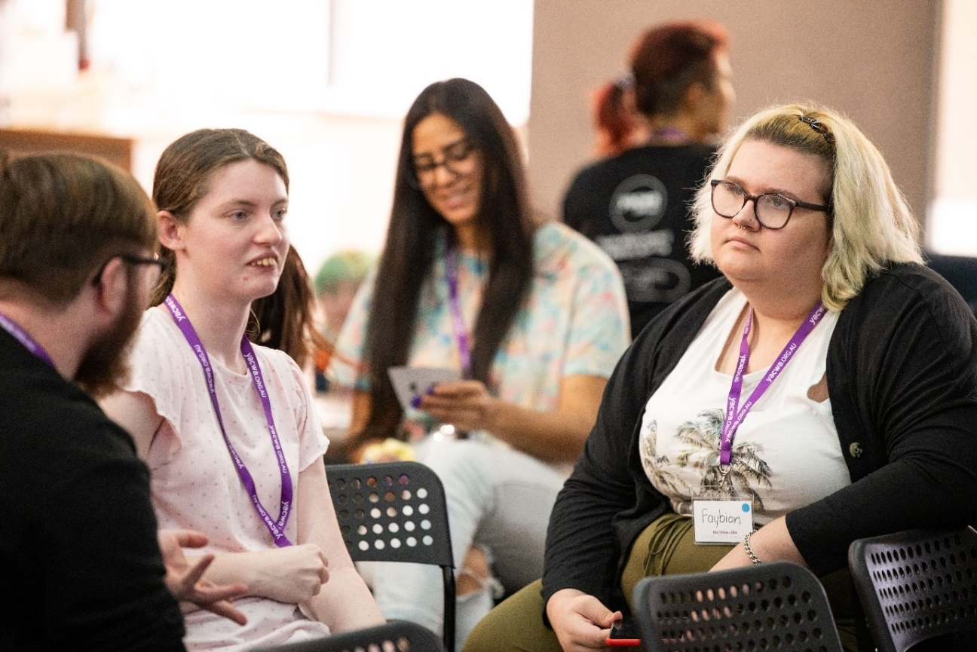

The Youth Steering Group

Recruitment
To recruit the Youth Steering Group (YSG), an online survey was created calling for expressions of interest and was open from June 2021, until July 2021. This survey asked questions about the young person’s:
- Background
- Demographic information
- History of engagement with mental health and alcohol and other drug services
- Reasons for wanting to participate in the project
- Current support networks
- Relevant skills and priorities
Recruitment involved screening for appropriate current support networks to allow them to manage their own care throughout the project. This included existing relationships with service providers (such as youth centres or counsellors), awareness of safety planning, and personal support networks.
Ten young people were selected to join the YSG representing a diversity of lived experience. Young people were selected to acknowledge different voices, and with a focus on ensuring they were in a ‘safe enough’ place to actively participate throughout the process. The YSG included representation from young people living in a regional area, LGBTIQA+ young people, culturally and linguistically diverse young people, young people living with a disability, young carers and parents, and Aboriginal young people.
All YSG members were employed as YACWA staff members on casual contracts at a Social, Community, Home Care and Disability Services Industry Award 2020 (“SCHADS Award”) level 1, pay point 1. YSG members were also provided access to YACWA’s Employee Assistance Provider, which was heavily promoted to all members throughout the process.
The YSG met a total of nine times between July and October 2021, with additional work being completed out-of-session and online.

Support
Support for the YSG was a complex and time-consuming process, but one that was necessary to enable their active participation, their professional development, and their safety across an emotive and sensitive project.
The YSG was provided significant flexibility to engage in the project how and when they were able. Throughout the project YSG members experienced life events such as study, the death of loved ones, relationship breakdowns, and more.
We regularly spoke with YSG members about how they were and if their expected work outputs needed to be adjusted/were on track. The group worked flexibly together to draw on current capacities to get the work done.
A support and self-care pack was provided to each YSG member at the start of the project. These packages contained a list of available community support services, sensory toys, journals, pens, and more. Importantly, these were also visibly given to YACWA project staff to model the need for self-care for all involved. These were later also given to metropolitan and regional summit participants.
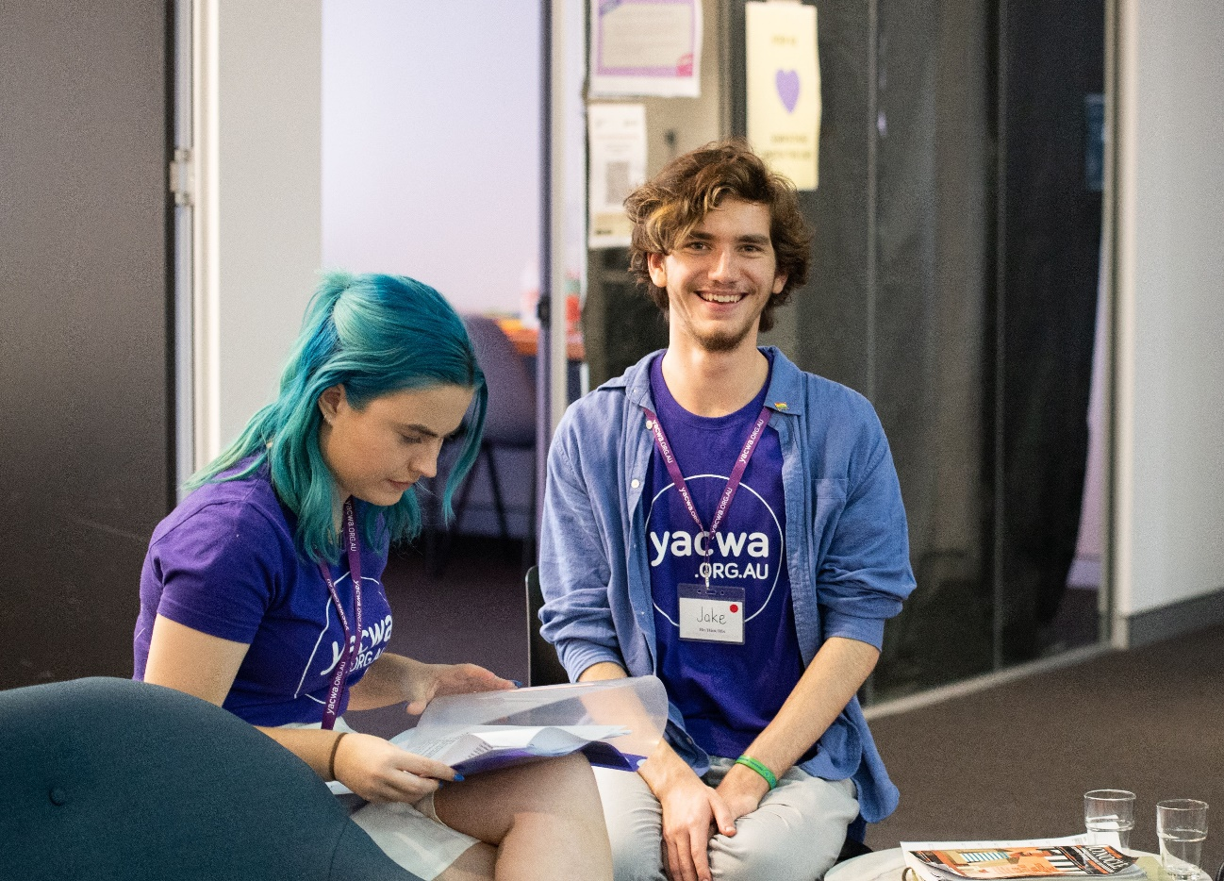

Essential Principles of Youth Service Design
Throughout all of the engagements, clear themes emerged that young people identified as critical and non-negotiable elements all policy, service design, and activities that impact young people—regardless of which priority is being implemented.
Young people indicated that the following themes are foundational to good practice and creating effective responses and supports for young people. In particular, these were important to ensuring services and supports integrated well into communities, were actively used by young people, and were able to support young people with a diversity of experience.
In order to provide adequate space and prominence to these themes, we have opted to highlight these as ‘essential principles’ that must underpin all activities relevant to the YPPA’s implementation. YACWA wishes for this section to reflect the significance of these that young people and the YSG impressed upon us. These were:
- Youth participation. Ongoing co-design and partnerships with young people is critical to success. Community consultation is not sufficient, and young people should be active decision-makers and empowered to shape solutions. The level of active decision-making power provided to the YSG and young delegates in this project was considered the gold standard that should be continued following the completion of the project. Co-design and partnerships with young people should be a mandatory element of all future youth service procurement and commissioning.

- Community partnerships. Effectively supporting the needs of diverse young people requires meaningful partnerships with existing community organisations and leaders. Diverse communities must be supported and empowered in the process, and not just be ‘recipients’ of government services. This should include engagement with and mapping of peak bodies, volunteer organisations, peer-led groups, and community groups currently operating in communities.

- Place-based approaches. Place-based approaches should be prioritised and resourced to ensure services and projects integrate with communities, supported by extensive mapping and community engagement prior to service commissioning. Methods such as Assets-Based Community Development and Collective Impact approaches were considered best practice for achieving true place-based design.

- Community expertise. Marginalised communities were seen as the experts in their own affairs and should be supported to make decisions around their wellbeing and were the ideal deliverers of specialised services. Where this is not possible, community organisations should be active participants in service design and management. Groups mentioned included:
  - LGBTIQA+ community organisations (such as Transfolk of WA and the Youth Pride Network)
  - Aboriginal Elders and Aboriginal Community Controlled Organisations
  - Multicultural (or ‘Culturally and Linguistically Diverse’) communities, including local leaders
  - Regional community organisations and champions.
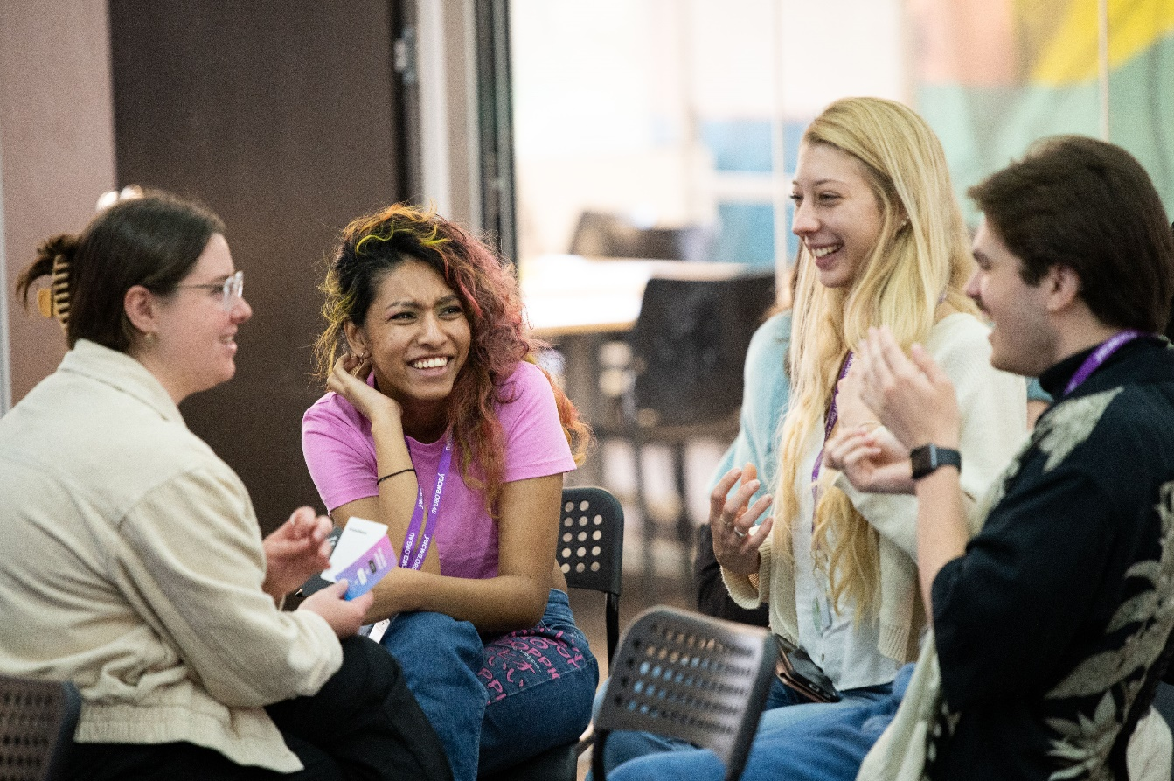

Metropolitan Summit Findings and Insights

Summary of Engagement
The metropolitan summit took place over two days in September and October 2021 at The Platform in the Perth Central Business District. In total, 31 young delegates from across the Perth Metropolitan area attended the Summit, supported by eight YSG members and five YACWA staff members.
Delegates were assigned to one of four groups to participate in closely over the two-day event. Each group was provided a specific ‘challenge question,’ which was to focus their discussions. The challenge question for each table summarised the key themes across a collection of similar or aligned priorities that engagement and insights were sought on from young people.
Young people were asked to complete the following activities across the two-day summit:
- User journey mapping. Identifying the key challenges, experiences, and needs of young people within the existing mental health, alcohol and other drug system in Western Australia. This included examining key touchpoints with the system and opportunities for change or improvements.
- Solution ideation. Co-creating a solution based on the groups’ shared discoveries, lived experiences, and values. This was informed by a pre-prepared presentation template that contained key headings and ideas for the groups to complete.
- Presentations to stakeholders. Presenting each group’s completed presentation to key stakeholders identified by the MHC and invited to attend day two of the summit. This was an opportunity for young people to provide their unique perspectives on their learnings and solutions directly to decision-makers.
- Stakeholder discussions. Targeted discussions with key stakeholders relevant to each group’s assigned priorities, allowing for stakeholders to ask questions and develop their understanding of young people’s views and proposed solutions.
In addition, each group was provided visual aids on the walls of the room to capture other insights and important reflections as the Summit progressed. This included a ‘persona map,’ building out different experiences, backgrounds, and characteristics of young people accessing relevant services, and a ‘parking lot’ for other insights that were considered important but not directly relevant to the purpose of the summit.
The four groups' themes were:
- Peer workers
- Family and domestic violence
- Workforce/workplace
- School and TAFE
The summaries below provide an overview of key highlights from the discussions and presentations of each group. By nature, these have missed many key elements of the discussions and the insights of the young delegates and facilitators that were part of a rich thread of conversation. In reading the below, we highly encourage the reader to review this alongside the presentations themselves provided in the appendix of this report.
A full run-sheet for the metropolitan summit as well as facilitators guide is provided at Appendix B and Appendix C respectively. A copy of the blank template provided for teams to deliver their presentation is located here.

Event Design and Safety
Event safety was a significant priority for the YSG. To support this, the following activities were undertaken:
- Event participants were given self-care packs including connection and support resources produced by Connection and Wellbeing Australia (CAWA).
- A sensory-friendly ‘chill zone' was created using blackout curtains, comfortable chairs, and warm lighting. Several participants commented on how important this was for them to manage their sensory input and anxiety.
- Visible signage on diversity was placed at the event’s entrance and throughout the room.
- Available supports were promoted at the start of the event and reaffirmed throughout the two days.
- A trained counsellor was always on-site and introduced to all young delegates as available without judgement. To support access, YACWA staff and YSG members were also promoted as available to support delegates to speak with the counsellor.
- External stakeholders were briefed prior to attendance on appropriate behaviour and the intended culture of the event, including a preference to dress casually, to respect and understand pronouns, and to be curious and affirmative about young people’s views.
- Activities such as the ‘elevator pitch’ were conducted with all young people present on Day 1, and then on Day 2 alongside external stakeholders to foster collaboration and comfort in complex tasks.
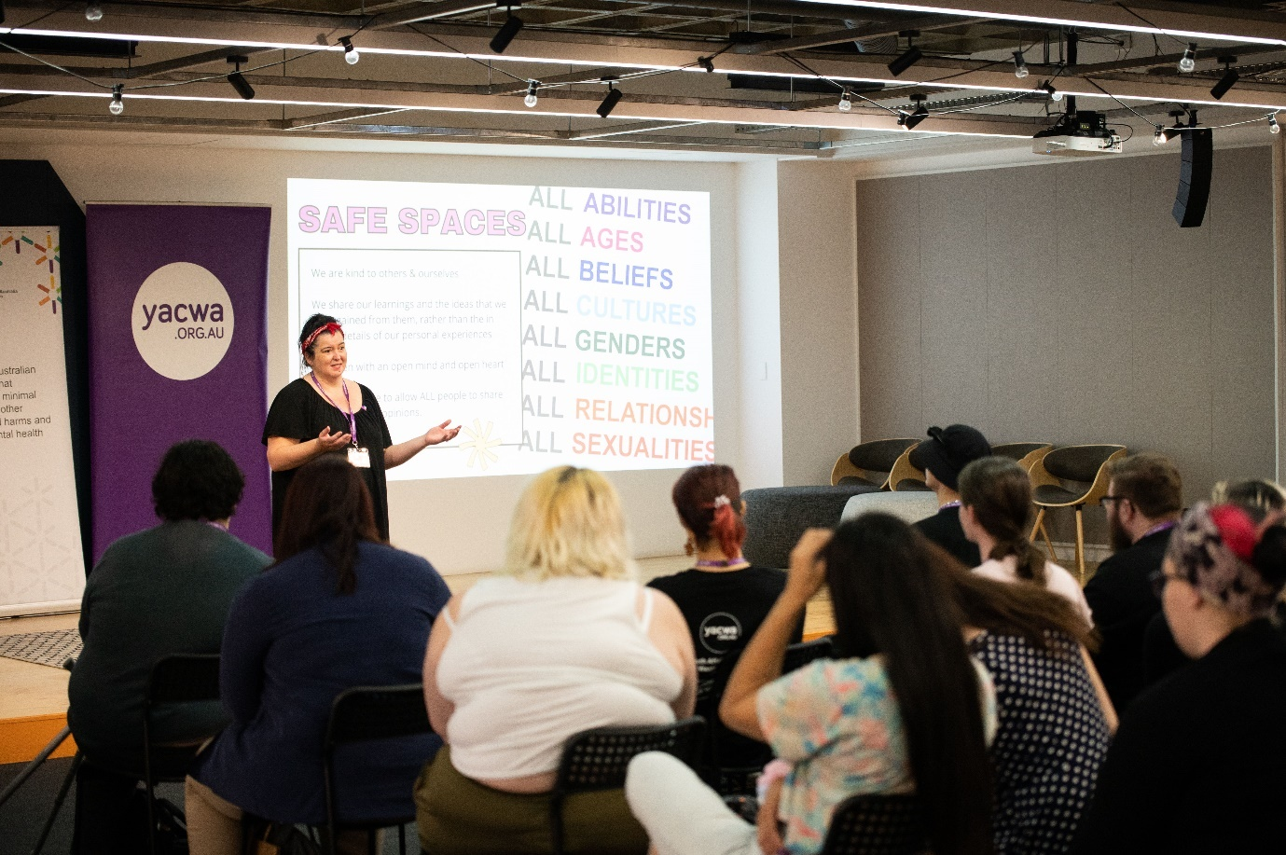

Group 1: Peer Workers

Challenge question
How might we develop and promote pathways to encourage young people to work and be supported as prevention and peer workers in the MH & AOD sectors? Specifically, considering the needs of peer & support workers in AOD transition services and LGBTQIA+ young people, young people from refugee and/or migrant backgrounds, Aboriginal young people, and young people living with disability.

Relevant priorities
# | Action
1 | Young people working in the mental health and AOD sector - Develop and promote pathways to encourage young people to work in the mental health and AOD sector, including in prevention and peer work.
2 | Peer workers - Establish system navigation/youth workers and/or youth mentors in emergency departments to support people and smooth transition to community system.
7 | Peer workers - Fund youth peer support programs for LGBTQIA+ young people, young people from refugee and/or migrant backgrounds, Aboriginal young people, and young people living with disability.
12 | AOD transition support workers - Expand youth after hours, outreach and transitional AOD treatment and support services, supporting young people to transition between services.

Overview of Themes
Enabling diverse and effective peer work requires foundational work with communities and a capacity-building approach
The delegates recognised that lived experience is diverse and intersectional, impacted by many life experiences, backgrounds, and cultures, in a similar vein to social determinants of mental health. The delegates wished to see peer work structures recognise this diversity and intersectionality, and actively engage with communities to ensure they were relevant, appropriate, and available to diverse young people.
Suggestions to support this included:
- Working with and consulting with diverse community leaders (particularly LGBTIQA+, people with disabilities, Aboriginal and Torres Strait Islander communities, refugee and migrant background communities)
- Creating direct recruitment pathways with existing community groups young people are already connected to
- Supporting the workforce to valued and recognise lived experience in more formal manners (such as through percentages of workforce with lived experience). One such example suggested was engaging with Aboriginal Community Controlled Organisations (ACCOs) and Aboriginal Medical Services to support their existing client base and networks to become peer workers within their services.
Young people felt this work would support a cultural shift in the way peer work and lived experience is understood in the sector. Young people felt that diversity of lived experience was not well understood or valued, and that there was little understanding of the unique experiences of different young people and communities, particularly Aboriginal young people. Young people wanted to see true partnership with communities to enable and encourage peer work within diverse cultural contexts and frameworks outside of traditional ‘clinical’ service models.
Young people with lived experience need to be informed that peer work is an option
As individuals with lived experience, many of the delegates felt that peer work was underpromoted and misunderstood. Many were unsure or unaware that peer work roles were available or valued within the sector or were not aware it was a viable career path and that could use their lived experience as a strength. There was an agreement among participants that adequately promoting peer work is a requirement to attracting a skilled workforce, while also having the benefit of providing many young people hope for a future career or that their experiences could be useful for their communities. Solutions included:
- Recognising and promoting peer work within school education and career curriculum alongside other career pathways
- Promoting existing peer support groups and services that are doing good work
- Promoting peer work opportunities and learnings within spaces young people are already engaged in to increase awareness (such as through community groups, social media platforms, and youth services).
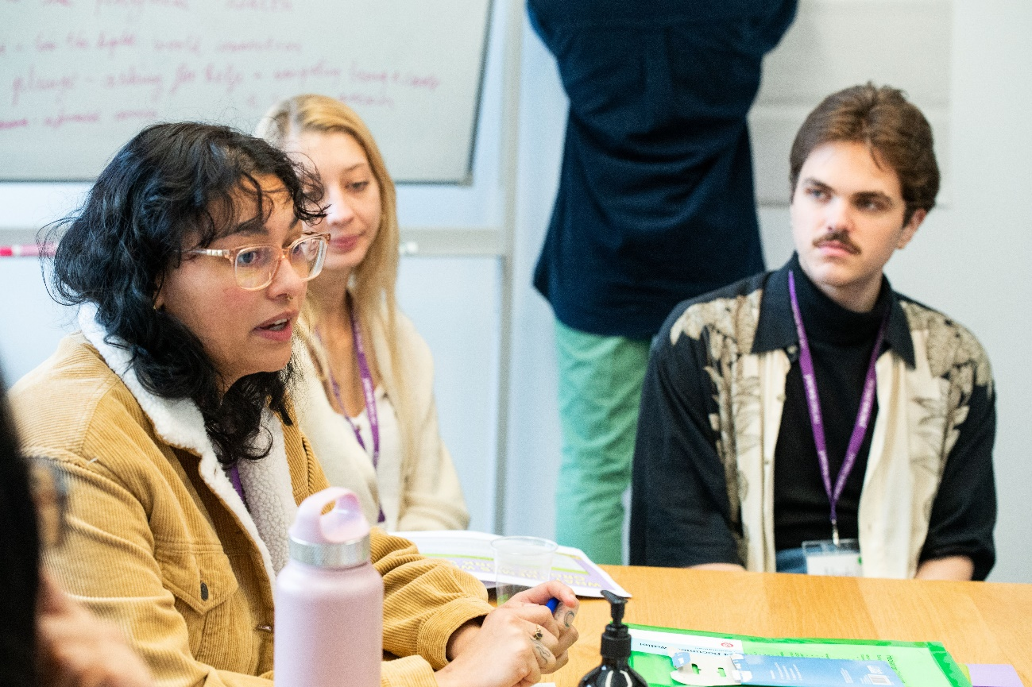
The needs of peer workers must be recognised and supported by organisations
In order to support a diverse, strong, and effective youth workforce in this space, organisations must value lived experience as a strength of workers in the sector, while also providing supports and structure to enable workers to manage and care for their own wellbeing while navigating this difficult space. This support should include fair pay for workers that recognises their expertise. Young people felt that peer work was often not compensated at the same rate as other roles with more formal qualifications, despite the difficult experiences and sophisticated learnings many peer workers had and brought to their roles.
Importantly, organisations must be willing to engage with and support lived experience to be part of their service workforce. Young people felt the system was ‘risk averse’ to supporting young people with lived experience and felt there was a lack of trust in their ability to judge their own readiness to undertake peer work.
Critically, young people identified that peers need specific support structures that understand their identities, cultural backgrounds, and experiences. They identified that it can be difficult to be a visible peer while also representing a marginalised community and wanted to see supports that were connected to their communities and understood their needs, such as an Aboriginal peer worker being connected to Aboriginal Community Controlled Organisations and counsellors who could understand their background.
Additional identified supports included:
- Peer-specific support structures within organisations
- Encouraging flexible pathways for young people to gain qualifications
- Creating ‘organic’ pathways to enter peer work that do not rely on educational qualifications
- Providing lived experience scholarships for those who wish to study further.
Peer support must be part of all systems of support
Young people identified that peer work should be embraced across the mental health, and alcohol and other drugs services sectors. Lived experience was considered a strength, and something that should be valued and enabled to shine across any role in the sector—regardless of whether the service was a ‘peer’ service. Young people particularly noted the need for peer support to be an option within crisis services, emergency departments, outreach, transition services, and psychosocial supports.

Identified Problems and Challenges
The following problems and challenges were identified by young people in this group:
- How do we help young people working as peers to deal with the reality of being affected by the same things they are helping others with?
- How do we remove financial barriers to gaining experience and qualifications?
- How do we make sure young people, and their lived experience are prioritised for roles?
- How do we protect young people from burnout?
- How do we ensure diversity within the peer workforce, and make sure their individual needs are considered?

Solution
The young delegates proposed a solution that did not sit within a single service but provided key principles and frameworks to ensure the sustainability of peer workers within our existing service system. The three principles they proposed were:
- Partner with existing communities, organisations, and community groups and support them to promote, engage with, and recruit peer workers in their own community contexts and environments.
- Promote peer work and the value of lived experience to young people in schools, services, and their networks.
- Create the support structures peer workers need to enter the workforce and remain healthy and well.

Non-negotiables
- Peer support options are a part of all systems of support—crisis services, emergency departments, outreach, transition services, psychosocial services, etc.
- Experience and diversity are valued and there is flexibility in enabling all young people to access qualifications and skills training
- Individual communities lead the process and are supported to enable champions of their community to be paid, supported, and trusted peer workers.

Group 2: FDV, AOD and Mental Health

Challenge question
“How might we develop MH, AOD and FDV systems that supports the intersectionality of the issues and experiences faced by young people? Especially when a young person faces all three of these challenges and needs a single service to understand how to support young people experiencing multiple challenges.”

Relevant priorities
# | Action
13 | Integrated family and domestic violence (FDV) and mental health and AOD services - Strengthen FDV services through integrating, co-locating or embedding mental health and AOD workers
14 | Co-occurring mental health and AOD:  - Progressively review all relevant existing models of service and procurement processes so that co-occurring mental health and AOD issues are addressed by a single service or a consortium of services, or effective pathways between different services are established.  - Adopt processes and guidelines for addressing co-occurring mental health and AOD issues in an integrated way, learning from those that have been established and applied in other States and Territories.

Overview of Themes
Schools and education providers are a key touchpoint for young people
Young people identified that schools and other education providers are a critical and important touchpoint in strengthening responses for young people within existing services. Schools were considered ideal as many young people had existing relationships with teachers that facilitate trust, honest conversations about their home lives, and therapeutic interventions.
However, the delegates felt that school staff were not currently supported to engage young people experiencing FDV, mental health, and AOD issues appropriately. Young people felt existing processes were too far removed from young people’s wishes and needs. To support this, they suggested embedding workforce development training within education staff.
They were also aware that it was almost impossible for schools, especially teachers to have a strong knowledge of all the services out there that could support young people, and wanted to see a hub, or single point of contact that schools could go to for this knowledge.
Education and workforce development can strengthen responses to FDV, mental health, and alcohol and other drug issues within existing structures
Delegates suggested a two-fold approach to supporting education to integrate with services in this area:
- Increased training to support teachers and school staff to identify signs of FDV, mental health issues, and alcohol and other drug use, allowing early intervention, and compassionate, discrete conversations with young people in safe environments.
- A focus on supporting young people to make decisions about their care and provided interventions, empowering them through a difficult period of their lives.
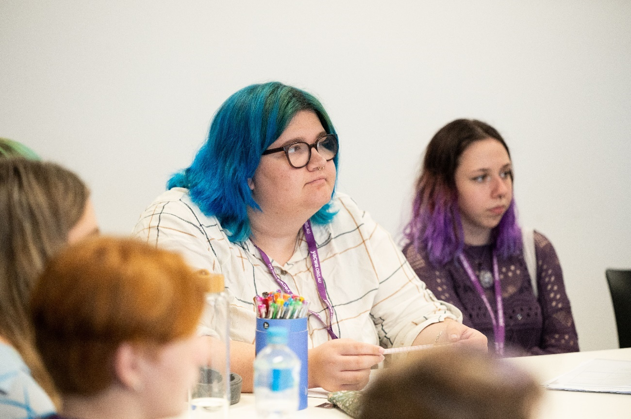

Identified Problems and Challenges
The following problems and challenges were identified by young people in this group:
- Young people’s experiences and viewpoints are not highly valued when FDV concerns are identified or suspected, with approaches focused more closely on risk avoidance. This results in young people feeling disempowered and a lack of control on their own journey.
- Many solutions for young people in this space are inappropriate for young people’s needs, including placement within adult wards, untenably long waitlists, and a lack of referral services following identification of FDV and mental health issues co-occurring.
- Long-term supports for young people are not prioritised or coordinated from a single point, resulting in young people having unmet needs following an immediate intervention.

Solution
Delegates solution in this group focused on the creation of a dedicated integrated referral service for young people experiencing the unique intersection of mental health, alcohol and other drugs, and/or FDV. This service would facilitate pathways between existing services, rather than adding an additional service that is restricted to a single locale. The integrated service would be a main point of contact schools. Additional key functions of the service were:
- Providing regular and ongoing workforce development training on identified capacity building needs
- Acknowledge the perspectives and needs of consumers and peer workers within its operations
- Provide resourcing and opportunities for a time-poor workforce to engage in professional development
- Focusing on early identification, prevention, and intervention to support young people early and prevent them from needing more crisis-oriented services

Non-Negotiables
- Referrals and services are integrated with pre-existing services, with a view towards scaling up and growing services that are currently operating and have strong community links.
- Integrate wellbeing practices into school education and curricula, supporting all young people engaged in education to increase their coping skills and learn harm reduction strategies around mental health, AOD, and FDV.
- Ensure ongoing training for teachers, police, nurses, and other relevant services and frontline responded in trauma-informed practice and FDV support and identification.
- Ensure services are accessible to young people, including:
  - Physical accessibility through strong public transport links and by allowing intake across multiple referral services and locales
  - Cultural accessibility through hiring a diverse and well-trained workforce that is accountable to inclusive practice
  - Environmental accessibility by designing a non-clinical and welcoming service environment.

Group 3: Workforce/workplace

Challenge question
How might we support the mental health needs of young people throughout the process of developing job skills, studying/training, finding work and being in the workplace? Specifically, consider the needs of young people from a diversity of backgrounds and communities, such as Aboriginal, culturally and linguistically diverse (CaLD), and LGBTQIA+ communities.

Relevant priorities
# | Action
8 | Diversity in the workforce - Review recruitment strategies to ensure the attraction and retention of a diverse workforce, including workers from Aboriginal, CaLD, and LGBTQIA+ communities.
9 | Mentally healthy workplaces - Implement the Thrive at Work program across Western Australian industry.

Overview of Themes
Mentally healthy workplaces must recognise young people’s unique position within workplace relations
Young people experience high rates of casualisation and are more likely to be engaged in volunteer or intern positions within workplaces. This, combined with their less-extensive employment history than older workers, was felt to create a power imbalance. Young people reported a reluctance to disclose their mental health issues or needs to their workplace for fear of reprisal (such as terminating their employment or cutting shifts).
They felt any approach to workplace mental health for young people needed to recognise these issues and provide for young people to be secure in their employment. They proposed solutions that mandated requirements around disclosing mental health needs or provided for alternative supports outside of the workplace.
Young people should be supported to care for their mental health both within and outsides of workplaces
Young people identified a desire for workplaces that were supportive of their mental health needs and said that they could be an excellent touchpoint to assist them in managing their mental health. However, they also recognised that for some young people, their mental health support was possibly best managed and cared for outside of the workplace.
Ideally, mentally healthy workplaces would provide the information, understanding, and flexibility for young people to choose how much involvement their workplace had regarding their mental health. One proposed example was for a workplace to ensure trained Mental Health First Aiders were among staff, while also promoting externally available services not linked to the workplace. This solution was seen as an empowering approach, allowing the young person to choose which avenue of care they pursued relevant to their own level of comfort and need. In many respects, this was about creating workplaces that could be flexible to meet individual needs, with no one-size-fits-all approach being suitable to every worker.
Community education programs must be designed by communities
One issue identified early by young people was that the Thrive at Work program was not considered appropriate or relevant to young people’s needs. Participants immediately questioned ‘why this program?’ and ‘how does this relate to young people?.’
From the discussions of participants at the summit—and from other discussions examining education and training programs—young people felt that any program engaging young people must be created by, adapted with, or led by the communities who were to benefit from it the most. For young people, they pointed out examples of the SafeTALK program that had been adapted to focus on LGBTIQA+ community needs. This was considered a more relevant program as it had been led by prominent and trained members of the LGBTIQA+ community and supported by additional community consultation to further refine it, which added trust in its relevance to the real needs of the LGBTIQA+ community in Western Australia.
Young people wished to see an employment program either developed from scratch with young people at the helm, or for an existing program to be adapted in partnership with groups of young people to ensure its relevance.
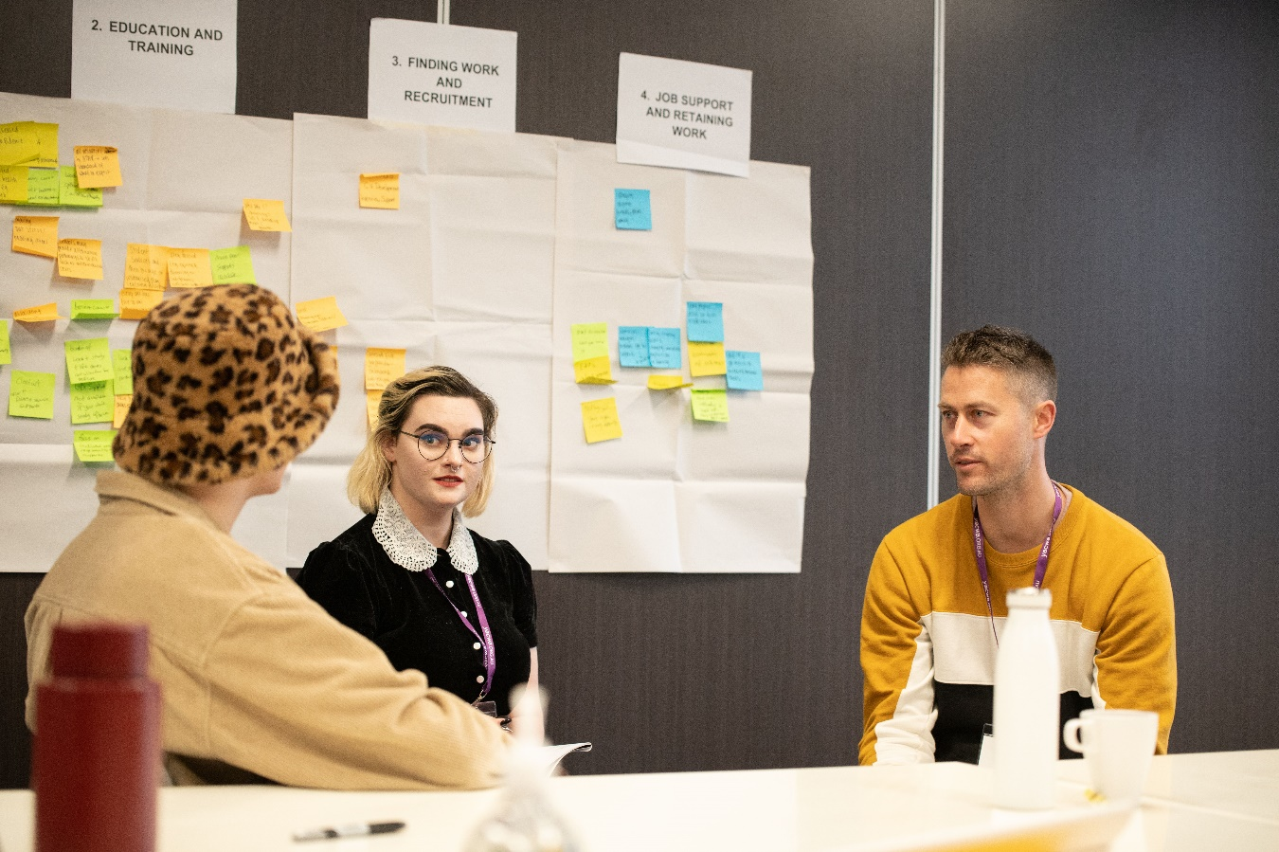

Identified Problems and Challenges
The following problems and challenges were identified by young people in this group:
- When young people experience mental health challenges within the workplace, they are often not empowered to make choices around the supports and flexibility they require.
- Young people will often not disclose their mental health challenges within the workplace due to discrimination or, just as importantly, fear of discrimination from their employer.
- Workplaces generally do not accommodate or support young people when they experience mental health challenges.
- Stigma regarding alcohol and other drug use is a significant issue within workforces, considered to be driven by a lack of understanding of the issue within the community.
- The Thrive at Work program was not well understood or recognised by young people and was considered possibly an inappropriate solution for young people’s needs. They wished to see more research on what this program was and wanted a review to determine its suitability.

Solution
A comprehensive education, awareness-raising, and support framework for youth mental health designed specifically for workplaces was proposed by the delegates. To be accredited under this framework, workplaces would be required to:
- Support workplace management to undertake youth mental health support and awareness training, such as Applied Suicide Intervention Skills Training or SafeTALK.
- Actively promote available supports to staff, aiming to combat stigma and fears of discrimination among workers.
- Provide additional leave for workers dedicated towards mental health support, providing recognition of the concept of parity of esteem.
- Provide information to workers of available support services outside of the workplace such as local counsellors, crisis lines, and community supports.
The delegates recognised that many of the levers required to support mentally healthy workplaces could not be solved by an individual program or service and required accountability and governance to support uptake. In particular they noted the following ideas would strengthen any workplace mental health program design:
- Expansion of the Mental Health Advocacy Service to provide increased support to young workers, and alternative avenues for recourse.
- Legislation to mandate additional leave specifically for mental health.

Non-Negotiables
- Any youth mental health training that is provided to workplaces should be co-designed with young people from diverse backgrounds to ensure it is appropriate and relevant to their needs. This should be ongoing and specifically include LGBTIQA+ young people, Aboriginal and Torres Strait Islander young people, young people with a disability, and young people from culturally and linguistically diverse backgrounds.
- Training and resources should be provided to staff across organisations, and not just within management.
- State Government agencies must take an active role in encouraging uptake of youth mental health supports and frameworks among workplaces, recognising their ability to mandate, legislate, or procure services as key drivers of change.

Group 4: School and TAFE

Challenge question
How might we empower young people with capacity building mental health & AOD education that will enable them to support themselves and others around them, in primary school, high school, and tertiary studies?

Relevant priorities
# | Action
11 | Evidence-based prevention activities in schools - Promote the following existing evidence-based prevention activities within schools:  - Response to Suicide and Self Harm in Schools Program  - School Drug Education Road Aware (SDERA)  - Aussie Optimism  - Teen Mental Health First Aid (MHFA) or other evidence based mental health literacy programs.
18 | The Department of Training and Workforce Development would like young people who are involved in TAFE to provide advice on what they expect TAFE and other relevant education/training providers to offer regarding supporting the mental health and wellbeing of young people (and reducing harm from AOD). How should these service be doing things differently to support young people?

Overview of Themes
Diverse staff can support confidence of young people to engage
Young people are a diverse cohort, with a range of diverse backgrounds, experiences, and values that impact upon their wellbeing and wellbeing outcomes. Young people from diverse backgrounds said they felt more comfortable engaging with staff or teachers from a similar background, as they usually had a greater understanding of their issues. This was particularly important for Aboriginal, CaLD, and LGBTIQA+ young people, who otherwise felt a need to ‘upskill’ the very people they sought support from on their unique needs.
Workforce training is critical to a whole-of-organisation approach
Delegates felt that staff and workforces within schools are the backbone of positive and mentally healthy environments. School staff are key contact points for all young people, and are able to contribute to cultural change, identify and support young people, and foster positive help-seeking behaviour. Delegates felt that without a strong focus on supporting the education sector’s workforce, any other procedural or policy changes would not be effective.
Schools must connect with external services to create sustainable referral pathways
While many issues experienced by young people can and should be identified within schools, young people said that not all issues should be dealt with by schools. In order to support young people to access the flexible and individualised help they need, the delegates wished to see schools have a strong understanding of available services in the wider community to support effective referral pathways. The additional benefit of this relationship was seen as supporting young people to develop therapeutic and supportive relationships outside of the school environment, contributing to positive wellbeing.

Identified Problems and Challenges
The following problems and challenges were identified by young people in this group:
- Primary schools lack the structures to build student capacity to understand mental health and AOD concerns or issues. Delegates felt there was an idea that primary school students are considered ‘too young to understand’ these issues.
- Young people felt school staff lacked awareness of youth mental health and alcohol and other drug issues or did not engage in these topics sensitively.
- Mental health or alcohol and other drug issues can lead to young people disengaging from education in various ways, including study deferral. Often, the ways in which young people disengage from education at higher levels (e.g. TAFE and university) can be subtle and may not be recognised by staff as signs of unmet need.
- A lack of diversity among education staff can hinder the ability of young people from marginalised backgrounds to disclose mental health issues or seek assistance. Many young people indicated that they felt safer speaking to someone of their own cultural background, but that this wasn’t always an option for them.
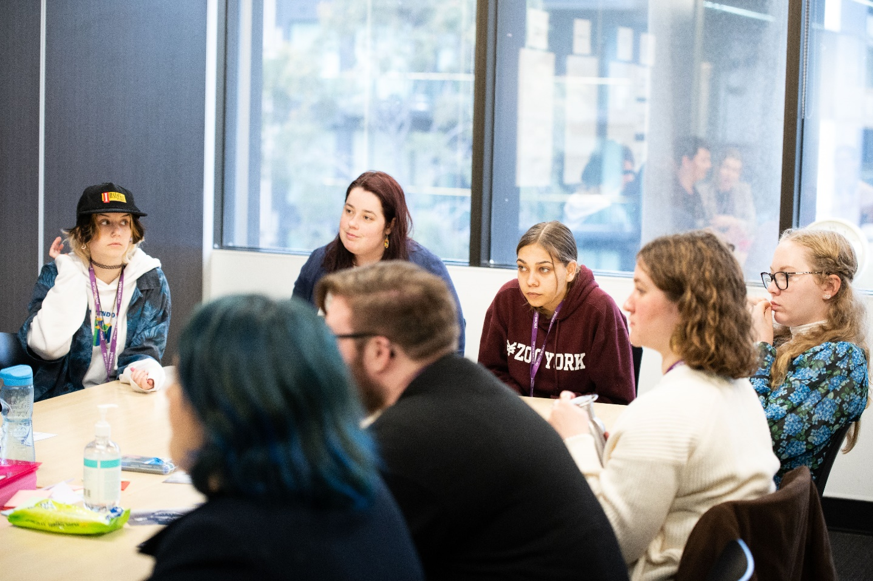

Solution
The delegates proposed a suite of solutions to support youth mental health within schools and TAFE. Each catered to the different age groups and environments across our existing education system.
For primary schools, the delegates designed a capacity-building approach focused on providing young people the skills, tools, and awareness needed for them to navigate their own mental health and encourage help-seeking behaviours early. To support this, they suggested:
- Providing trauma-informed care training for all school staff, supporting educators and administrative staff to understand students’ individual experiences, work flexibly to meet their needs, and increase student safety.
- Increasing training and structural supports for LGBTIQA+ young people, recognising that gender diverse and trans young people face high levels of discrimination that contribute to poorer mental health outcomes. This included ensuring accessible and gender-neutral bathrooms in school environments and normalising behaviour change shifts around pronoun usage.
- Ensuring schools are connected with existing services in the wider community, allowing swift and appropriate referral to specialised services for young people as needed. This was seen as critical for success.
For high schools, students suggested a hands-on approach to incorporating mental health and alcohol and other drug education into school curriculum, alongside clear guidelines and requirements of available staff and supports within school environments. To support this, they suggested:
- Embedding mental health awareness training within health curriculum to support young people to recognise signs and symptoms of mental illness or alcohol and other drug use and build their confidence to find and access help early.
- Mandatory staff training to support staff to identify and refer students to appropriate supports. Accredited mental health training packages such as Youth Mental Health First Aid and SafeTALK were suggested.
- Minimum standards for supports within schools, such as mandating one psychiatrist per school in a clinical lead role, educational requirements for staff (such as a Certificate IV in Mental Health or equivalent) in high-contact positions, alongside clear confidentiality requirements that support student safety and confidence in engaging with staff on contentious issues.
For universities and TAFEs, similar solutions were suggested with a focus on workforce development.

Non-Negotiables
- Schools must be connected with the existing service landscape for young people, supporting appropriate referrals to meet needs. Not all issues can or should be supported by schools, and these links will support young people to build their capacity to manage their own mental health while increasing their awareness of available supports.
- Flexibility in responses to young people’s needs. Schools must be supported and able to provide appropriate care.

Regional Summit Findings and Insights

Summary of Engagement
The regional summit took place over one day in October 2021 and was held virtually over the videoconferencing platform Zoom. In total, 12 delegates from across Western Australia attended the summit, supported by seven YSG members and two YACWA staff members.
Delegates were assigned to one of three groups to participate in based on their experiences, interests, and backgrounds. Each group was provided a specific ‘challenge question,’ which was to focus their discussions. The challenge question for each table summarised the key themes across a collection of similar or aligned priorities that engagement and insights were sought on from the young people.
The three groups' themes were:
- Peer workers
- Lifespan
- Stigma and discrimination
The summaries below provide a brief overview of key highlights from the discussions and presentations of each group. By nature, these have missed many key elements of the discussions and the insights of the young delegates and facilitators that were part of a rich thread of conversation. In reading the below, we highly encourage the reader to review this alongside the presentations themselves provided in the appendix of this report. A full run-sheet for the regional summit is provided at Appendix D. A link to the Canva presentation delivered through sharing the screen with the regional participants can be accessed here.

Group 1: Peer Workers

Challenge question
How might we develop and promote pathways to encourage young people to work and be supported as prevention and peer workers in the MH & AOD sectors? Specifically, considering the needs of peer & support workers in AOD transition services and LGBTQIA+ young people, young people from refugee and/or migrant backgrounds, Aboriginal young people, and young people living with disability.

Relevant priorities
# | Action
1 | Young people working in the mental health and AOD sector - Develop and promote pathways to encourage young people to work in the mental health and AOD sector, including in prevention and peer work.
2 | Peer workers - Establish system navigation/youth workers and/or youth mentors in emergency departments to support people and smooth transition to community system.
7 | Peer workers - Fund youth peer support programs for LGBTQIA+ young people, young people from refugee and/or migrant backgrounds, Aboriginal young people, and young people living with disability.
12 | Diversity in the workforce – Review recruitment strategies to ensure the attraction and retention of a diverse workforce, including workers from Aboriginal, CaLD, and LGBTIQA+ communities.

Overview of Themes
Young people require support to maintain appropriate boundaries and care for themselves when new to peer-based roles
The delegates identified from their experiences (both lived and observed) that many young peer workers struggle with personal boundaries within their roles, often arising from an abundance of compassion. They wished to see youth peer work fostered and to increase, but to do so with a view to keeping workers healthy and supporting them in navigating the difficult space.
Young people spoke of the views many of them had as peers, feeling a need to ‘fix’ clients, or go beyond the call of their job to meet other young people’s needs. They wished for clearer guidance on how to establish these boundaries, and to see them put into practice through mentor arrangements. Without these supports, young peer workers were considered likely to burn out early and exit the workforce.
Peer workers face additional challenges in regional areas
The delegates discussed the issue of stigma within regional areas and communities as being more pernicious and difficult than in metropolitan areas because of the size and close-knit nature off their communities. The participants indicated that engaging in peer work could ‘out’ their lived experiences and may result in bullying or discrimination from others.
They wished to see community attitude change through awareness campaigns within regional areas to support a shift and encourage more peer workers.

Identified Problems and Challenges
The following problems and challenges were identified by young people in this group:
- There are a variety of barriers for young people (and individuals of all ages) to become peer workers. These include:
  - Financial barriers towards educational costs
  - Metropolitan-centric training options being unavailable in regional areas
  - A lack of intersectional approaches or expertise within organisations and education opportunities
  - Lack of awareness or promotion of peer worker opportunities
- Engaging in peer workplaces, young people at risk of burnout if workloads are high and there is insufficient support for them to manage their own mental health.
- A reliance on voluntary work in peer-based positions makes it difficult to retain skilled and passionate individuals. This is exacerbated in regional areas which rely more on volunteer workers due to insufficient funds and workforce availability issues.
- Regional areas lack lived experience being championed or promoted among mentorship programs.
- Stigma within regional communities can act as a social barrier to young people entering the peer workforce due to a fear of discrimination or bullying.

Solution
Delegates proposed a three-part solution focused on supporting young people to become sustainable and valued peer workers within our mental health, alcohol and other drug workforce:
- Increasing accessibility of existing training through:
  - Providing training through existing groups and organisations that are connected with young people with lived experience, such as schools and community groups.
  - Ensuring training opportunities are provided in locations with strong public transport links.
  - Providing clear boundaries in training of what is and isn’t expected within the role of peer work (e.g. peer workers are not expected to ‘fix’ the client).
- Creating tailored regional training and work opportunities that meet local needs through:
  - Engaging closely with young people within specific communities before creating new services to develop an understanding of what is needed and what will support young people to engage with whatever is designed or procured.
  - Prioritising youth ‘drop-in’ services and hubs that value a conversational and casual environment that is non-clinical.
  - Empowering young people to design and deliver activities within communities in a ‘by young people, for young people’ model.
  - Conducting community outreach events to connect with young people in environments they are already frequenting.
- Developing co-designed systems of support for young peer workers, including:
  - Mentoring systems that provide interpersonal support
  - A focus on addressing burnout and supporting self-care
  - Assisting young peer workers to establish and maintain professional boundaries
  - Fostering career opportunities within regional areas to support young people to develop and grow within their roles.

Non-Negotiables
- Peer workers are provided clear boundaries about what is and isn’t within their role.
- Services are tailored to individual regions through community conversations and partnerships with existing resources (i.e. don’t ‘homogenise’ regional Western Australia).
- Services need to be empowered to provide young peer workers with the right supports, meaning a level of flexibility.

Group 2: Lifespan

Challenge question
How might we empower young people with capacity building mental health & AOD education that will enable them to support themselves and others around them, in primary school, high school, and TAFE? How can we ensure that peers deliver these sessions?

Relevant priorities
# | Action
11 | Evidence-based prevention activities in schools - Promote the following existing evidence-based prevention activities within schools:  - Response to Suicide and Self Harm in Schools Program  - School Drug Education Road Aware (SDERA)  - Aussie Optimism  Teen Mental Health First Aid (MHFA) or other evidence based mental health literacy programs.
9 | Mentally healthy workplaces - Implement the Thrive at Work program across Western Australian industry.
8 | Diversity in the workforce - Review recruitment strategies to ensure the attraction and retention of a diverse workforce, including workers from Aboriginal, CaLD, and LGBTQIA+ communities.

Overview of Themes
Viewpoints on mentally healthy schools were similar to the metropolitan summit
Both groups in focusing on schools clearly identified the need for mandatory training and a consistent framework for how schools can provide mental health information and supports. Both metropolitan and regional participants emphasised the need for this to be mandatory and structured at a high level in order to ensure the supports met the needs of young people.
Participants were unaware of the Thrive at Work program
As in the metropolitan summit, participants had not encountered the Thrive at Work program and were unsure if it would meet their needs. Young people asked questions about its relevance and content, and if it would enable structural and cultural changes within workplaces. They felt it was important that young people had a strong say in the design of a mentally healthy workplace program.

Identified Problems & Challenges
The following problems and challenges were identified by young people in this group:
- Young people face many challenges within the school environment that can lead to poor mental health outcomes, including:
  - Bullying
  - Struggling to belong in a changing social environment
  - High levels of stress and expectations to achieve academically
  - Peer pressure to use alcohol and other drugs
- Many young people lack access to high-quality and trusted information about mental health, alcohol and other drugs.
- Many young people lack access to trusted and supportive adults to speak to about their concerns.
- Young people lack the tools to access services the way adults do, including fewer transport options, and managing costly service access despite a lack of financial independence.

Solutions
This group had three key solutions:
- Mandatory mental health (including suicide awareness and intervention) training for school staff. This should include principals, teachers, education assistants, and any staff who engages with young people in any form.
- Mandatory mental health and alcohol and other drug education within school curriculum, supporting:
  - Increased knowledge of help-seeking behaviours and available local services
  - Honest discussions around mental health beginning in late primary school
  - Honest discussions about alcohol and other drug use beginning in early years of high school
  - Lived experience speakers to speak directly to students and staff of their journeys and to model help-seeking behaviour.
- Mandatory safe spaces within school environments to meet young people’s needs. These should include sensory toys, quiet spaces, and access to a counsellor or support staff person. Importantly, schools should be provided flexible guidelines to help them create these spaces in accordance with young people’s views and best practice.

Group 3: Stigma & Discrimination

Challenge question
How might we empower young people with capacity building mental health & AOD education that will enable them to support themselves and others around them, in primary school, high school, and TAFE? How can we ensure that peers deliver these sessions?

Relevant priorities
# | Action
17 | Dep Local Government, Sport and Cultural Industries (DLGSC) would like young people to provide advice regarding how stigma, discrimination and racism can be addressed (relates to 1.8, 1.9, 4.12, 4.13).
19 | DLGSC would also like young people to provide advice on culturally secure practices, in particular, what do culturally secure services look like, how can that be articulated, what should procurement practices include to ensure services are culturally secure (4.3, 4.8).

Overview of Themes
Community champions can support anti-discrimination practice
Young people felt that challenging stigma, discrimination, and racism required community leaders to be on board and appropriately trained. Examples giver were local groups, such as Scouts or sporting groups, where young people wished to see referees, leaders, and volunteers all contributing to the task of battling discrimination.
Young people felt these roles were highly visible and modelled positive behaviour for other young people. Their roles as leaders also allowed them to enforce good behaviour and call out stigmatising language or discrimination when they saw it, which contributed to accountability. Young people wanted to see more visible individuals within communities supported to champion inclusion and mental health through training.
Combatting community stigma in regional areas first requires accessible services
Conversations about stigma and discrimination among regional communities repeatedly turned back to the issue of a lack of available services for young people. Young people felt strongly that while stigma and discrimination were an issue in communities, it needed to be addressed in tandem with ensuring equitable service access.
Young people hoped for place-based service design that partnered meaningfully with local communities to determine what needs they had. Upon reflection from facilitators around collective impact and assets-based community development approaches, young people were supportive and stressed that it was critical any procurement or service design processes engage with those already within the community beforehand.

Identified Problems & Challenges
The following problems and challenges were identified by young people in this group:
- Stigma in the workplace may lead to fear of losing job security if seeking help—it is not always safe to speak up. Fear of discrimination can cause its own barriers, regardless of if the community is safe.
- The culture of some regional communities actively discourages honest conversations about mental health or alcohol and other drug use, such as through using humour to deflect the issue.
- Small communities can lead to problems of word getting around and can make it hard to seek help.
- Online help-seeking is not always an option in regional areas, with many facing internet issues or a lack of digital devices.

Solutions
This group developed the following solutions:
- Introducing an Australian wide service that has mental health advisors who are assigned different young people to connect with and help them in their specific needs. Keeping in mind what works for some does not work for others
- Mentoring systems for regional areas (could be facilitated online) to help people have someone to talk to whom they trust, and feel won’t discriminate or judge them for their concerns. It was important these mentors were considered part of the fabric of their communities, as they could challenge assumptions about the wider community through the act of providing support.
- Utilising pre-existing services (e.g. Suicide Prevention Centre, Beyond Blue, etc.) to have diversity and inclusivity campaigns in regional WA—this could include a focus on mindfulness in community outreach
- Peer training available for leaders and peers, to ensure safe conversations and positive mental health within sport and community groups, including for unique groups (LGBTIQA+ young people, neurodiversity, etc.).

Non-Negotiables
- Long term, culturally informed training, and for people to be held accountable for engaging in training
- Active involvement from different populations within the community, and it should be specific to different communities (not one size fits all!)
- All members that are a part of the organisation should be involved, people at all levels need to be on board
- Leaders who can empathise, and who can champion work

Additional Engagements Findings and Insights

Summary of Engagement
YACWA was contracted to conduct up to 10 instances of additional youth engagement activities on specific priorities that focus on one cohort or location. These additional points of engagement were across a variety of platforms and encompassed both face-to-face and online engagement. Additional points of engagement were determined through a number of mechanisms. These were:
- Groups identified as underrepresented in existing consultation.
- Considered important voices requiring a dedicated space and time to unpack key experiences by the YSG; and
- Relevant to specific YPPA priorities that would benefit from additional engagement.

Engagement 1: Regional Young People (Pilbara)
Format: Online survey (13 responses) and 11 individual conversations
Date: 27 August 2021
Theme: Unique needs of youth services in regional areas
Overview: This engagement occurred via online survey and individual conversations held in the Karratha area. This was able to occur due to travel for an external project being delivered by the consultant. Eleven conversations took place, with five occurring at the YOH (‘Youth On Health’) Festival and six occurring as part of the LGBTIQA+ Regional Mental Health workshops delivered in partnership between WAAC (formerly the WA AIDS Council), CAWA, and the Y (formerly the YMCA).

Relevant Priorities
# | Action
1 | Young people working in the mental health and AOD sector - Develop and promote pathways to encourage young people to work in the mental health and AOD sector, including in prevention and peer work.
2 | Peer workers - Establish system navigation/youth workers and/or youth mentors in emergency departments to support people and smooth transition to community system.
3 | Specific training regarding supporting children and young people - Develop and provide relevant training in supporting and treating children and young people with mental health and AOD issues (e.g., school nurses, GPs, Mental Health Co Response, Emergency Department staff etc).
4 | Culturally secure services - Invest in Aboriginal Community-Controlled Health Services (ACCHS) Social and Emotional Wellbeing programs, developed and led by Aboriginal people and their communities, across all regions of the state.
7 | Peer workers - Fund youth peer support programs for LGBTQIA+ young people, young people from refugee and/or migrant backgrounds, Aboriginal young people, and young people living with disability.
8 | Diversity in the workforce - Review recruitment strategies to ensure the attraction and retention of a diverse workforce, including workers from Aboriginal, CaLD, and LGBTQIA+ communities.
9 | Mentally healthy workplaces - Implement the Thrive at Work program across Western Australian industry.
12 | AOD transition support workers - Expand youth after hours, outreach and transitional AOD treatment and support services, supporting young people to transition between services.
17 | The Department of Local Government, Sport and Cultural Industries would like young people to provide advice regarding how stigma, discrimination and racism can be addressed (relates to 1.8, 1.9, 4.12, 4.13).

Overview
Crisis and support services
- Young people felt there were not enough local support services, especially for crisis situations.
- Young people expressed they were afraid to access emergency support as they did not know what to expect if they did engage, including what supports would be offered, who in their community would ‘find out’ they had accessed the service, and whether they could be supported in their own community without travelling to the metropolitan area.
Peer Workers
- Young people did not feel there were easy pathways in becoming peer workers and did not see opportunities to choose this as an option.
- Not all services available locally were viewed in a positive light, which dampened their interest in working for them, even if peer work opportunities were available.
- Training or paid work experience opportunities were unheard of or scarce and were felt to be under-promoted if they were available.
Education
- Many young people see gaps in education in schools in the region about mental health, but especially about eating disorders and AOD.
- They felt that adults (including both teachers and families) did not know how to talk about mental health or alcohol and other drug use.
- Young people felt other young people believed many stereotypes and misinformation around mental health or alcohol and drug use and felt this led to bullying of those known to have these challenges.
- Young people said that schools may have one or two teachers that know about sex, sexuality and gender, but other staff did not recognise or respond to bullying and discrimination.
Workplaces
- Young people reported that their workplaces did not do much to support their mental health and they were fearful of retribution if they spoke up about needing time off or flexibility for their mental health (or to care for others). Fears included losing shifts or being fired. These were exacerbated by working casual arrangements and requiring income to maintain their study or other life commitments.
- Balancing the need to earn money by working and the demands of school also negatively impacted their mental health.
- Events such as ‘R U OK Day’ were common in workplaces but were viewed negatively as insufficient or not supporting action outside of the day.
Primary Health
- All of the young people reported their GPs not understanding mental health, alcohol and other drug use, or eating disorders.
- Additionally, GPs were felt to lack understanding about Aboriginal communities, LGBTIQA+ young people and young people from refugee or migrant backgrounds and cultures. For many, this was a critical competency that was needed to support them to engage, let alone disclose mental health or AOD concerns.
- Many reported their own (or those of their friends) experiences of discrimination from health workers. Young people said their friends often did not seek help if they were from diverse communities as they felt they would face multiple discriminations and staff that didn’t understand them.
Community
- Young people were concerned that if you weren’t involved with things like local sport and youth things like headspace that young people lacked opportunities to seek help or talk about their mental health with people who were informed.

Identified Problems and challenges
The following problems and challenges were identified by young people in this group:
- A lack of education about mental health, AOD, eating disorders and identity
- No structured LGBTIQA+ learning for education, service providers and community
- Racism not talked about in the area
- A lack of pathways to enter into peer roles
- Parents and carers not having basic knowledge about how to best support young people

Solutions
Young people identified the following solutions:
- Local ‘champions’ of mental health that are trained in all these topics, as well as culture, disability, LGBTIQA+. They said that these peers could be connectors between young people and services, but they would need a lot of support on how to deal with this role
- Basic education for all health, mental health and education services on LGBTIQA+ young people.
- In depth education about mental health, suicide prevention, eating disorders, AOD, healthy relationships to be provided to young people. They said that these need to be delivered in a way that young people understand and that can support them to help themselves and their friends.
- A campaign for mental health at work for young people that encourages employers and employees to work together and know what rights they have.
- Provide peer workers in AOD transition to make it easier for young people to access services. A project that recruits and trains them as ambassadors would be a great start

Non-Negotiables
- Diversity training for services that is mandatory and delivered with young people
- Workplace mental health support needs to work for young employees, especially casuals
- All services should have diverse staff and cultural connectors (for Aboriginal folks, LGBTIQA+ people with disability etc) that can act as advocates

Engagement 2: Public Health Campaigns (Youth Steering Group)
Format: Online Survey (5 responses)
Date: 18 October 2021 – 26 October 2021
Theme: Capacity building and consultation with young people
Overview: The YSG had significant reflections on the topic of youth engagement and public health campaigns, based on their experiences in designing the project. The YSG wished to provide this feedback in detail and requested a dedicated opportunity to unpack their experiences and learnings to underpin all further youth engagement activities under the YPPA’s implementation. The below priorities are most relevant to this engagement; however, these findings relate more broadly than these discrete priorities.
Relevant Priorities
# | Action
5 | Expanded state-wide campaigns and related community action in order to:  - Reduce alcohol related harm.  - Minimise the risk of harms relating to drug use.  - Raise awareness of social and emotional wellbeing and the harms associated with AOD use among young Aboriginal people, their families and communities, such as through the Strong Mind, Strong Spirit metropolitan project.
9 | Mentally healthy workplaces - Implement the Thrive at Work program across Western Australian industry.
20 | WA Police are interested to know how young people want to be consulted/engaged regarding issues that impact them? This could look at particular priority groups (e.g. those in contact with the justice system).
11 | Evidence-based prevention activities in schools - Promote the following existing evidence-based prevention activities within schools:  - Response to Suicide and Self Harm in Schools Program  - School Drug Education Road Aware (SDERA)  - Aussie Optimism  Teen Mental Health First Aid (MHFA) or other evidence based mental health literacy programs.

Overview
Alcohol and Other Drugs Education
- Young people valued harm minimisation approaches that empowered them to make their own choices through education.
- Respondents valued the following in AOD education:
  - Information on recognising warning signs of substance abuse and addiction early
  - Guidance on how to support family/friends.
  - Experiential and hands-on learning (such as workshops, roleplays, and physical exercises) as opposed to workbook-based learning.
  - Healthy and safe habits for those who do choose to consume alcohol or other drugs (such as understanding alcohol content, warning signs of overdose, and planning appropriate transport).
Mental Health Education
- Suicide was seen as an underrepresented topic, and young people wanted to see this stigma actively addressed in education around mental health. This included recognising warning signs, understanding protective and risk factors of suicide, and supporting young people to navigate the complexities of disclosing suicidal ideation.
- Respondents valued the following in mental health education:
  - An evidence-based and sensitive approach to suicide that was unafraid to examine the topic in detail.
  - Information on self-care and resilience in practical settings.
  - How to create safety plans and supports.
  - Clear access to a counsellor or support person when discussing mental health.
Mentally Healthy Workplaces
- Information on young people’s rights, responsibilities, and financial entitlements were considered important to creating a supportive and transparent culture within a workplace.
- Mentally healthy workplaces should promote available services and supports, both within (e.g., on-site Mental Health First Aiders) and outside of the workplace (e.g. local counselling services).
Youth Engagement
- Co-design should be a prioritised in all youth initiatives, and appropriately resourced (including flexible timeframes) to enable shared discovery and engaging diverse voices and experiences.
- Pro-active engagement was valued, where young people were followed up by services following the last engagement to demonstrate their insights were valued.
- Social media is a valuable tool to engage young people in a variety of contexts, including public health campaigns and service promotion.
- Paid participation is critical for many young people to engage in co-design or consultation activities. For many young people, when opportunities are not paid they must make a choice between having their voice heard or being able to pay their rent or bills on-time.

Engagement 3: LGBTIQA+/TGD
Format: Online survey (15 responses) and focus group
Date: 18 October 2021 to 31 October 2021
Theme: Safe and inclusive services for LGBTIQA+ young people
Overview: Leading LGBTIQA+ community organisations were recognised by the YSG to currently be providing high-quality services and supports, often without funding. The following groups were engaged: TransFolk of WA, Youth Pride Network, Bi+ Community Perth, WAAC (formerly WA AIDS Council), Freedom Centre (hosted by WAAC), and PFLAG Perth. Additionally five young LGBTIQA+ were spoken with in a dedicated focus group held in Esperance on 30 and 31 October 2021 as part of an externally funded LGBTIQA+ youth mental health workshop delivered by CAWA, WAAC, The Y, at Headspace Esperance.

Relevant Priorities
# | Action
1 | Young people working in the mental health and AOD sector - Develop and promote pathways to encourage young people to work in the mental health and AOD sector, including in prevention and peer work.
3 | Specific training regarding supporting children and young people - Develop and provide relevant training in supporting and treating children and young people with mental health and AOD issues (e.g. school nurses, GPs, Mental Health Co Response, Emergency Department staff etc).
7 | Peer workers - Fund youth peer support programs for LGBTQIA+ young people, young people from refugee and/or migrant backgrounds, Aboriginal young people, and young people living with disability
8 | Diversity in the workforce - Review recruitment strategies to ensure the attraction and retention of a diverse workforce, including workers from Aboriginal, CaLD, and LGBTQIA+ communities.
13 | Integrated family and domestic violence (FDV) and mental health and AOD services - Strengthen FDV services through integrating, co-locating or embedding mental health and AOD workers
15 | Department of Health (DoH) would like the young people engaged as part of the YPPA youth engagement activities to focus on providing input into how health services (particularly mental health/AOD) are inclusive and responsive to people from the LGBTQIA+ priority group. In particular, it would be useful to seek their input regarding what sort of staff training would be helpful, and ways services can be more inclusive. This aligns to various YPPA Top Priorities as well as various election commitments DoH have been tasked with
16 | Dep Local Government, Sport and Cultural Industries (DLGSC) would like young people to provide advice regarding how stigma, discrimination and racism can be addressed (relates to 1.8, 1.9, 4.12, 4.13)
17 | DLGSC would also like young people to provide advice on culturally secure practices, in particular, what do culturally secure services look like, how can that be articulated, what should procurement practices include to ensure services are culturally secure (4.6, 4.8)

Overview
LGBTIQA+ Young People Require Inclusion to Be Highly Visible
- There is a lack of representation and visibility in the community with young people not seeing an open presence of the LGBTIQA+ community or of ally support
- Many young people reported experiencing past discrimination and lack of inclusive practice in health and mental health settings. This affected their likelihood of engaging with future services. Young people assumed that services were not inclusive of LGBTIQA+ issues by default unless otherwise signalled to be inclusive.
Mandatory LGBTIQA+ Inclusive Education in Schools
- Inclusive education was considered highly important, and many young people wanted education on LGBTIQA+ issues and inclusion to be a mandatory element of all schools and workplaces.
- Young people valued the involvement of LGBTIQA+ people in designing and delivering any form of training. There was a preference for lived experience to be highlighted or platformed in education to build empathy and support community visibility.
- The highly politicised controversies around the Safe Schools program had negative impacts on the health and wellbeing of many LGBTIQA+ young people. The defunding of Inclusive Education WA was mentioned as a loss, with some young people feeling their wellbeing was not valued by their community.
LGBTIQA+ Community Support
- Young people were very positive when speaking about LGBTIQA+ community groups operating in WA, particularly the Youth Pride Network, Transfolk of WA, and Freedom Centre (run by WAAC).
- Young people wanted to see greater support for community-led initiatives, and for new developments to partner with these groups to avoid duplication. These groups were seen as more authentic and trustworthy than government-run services.
- Active and visible community-run organisations were powerful protective factors for wellbeing. Young people felt they provided role models and demonstrated hope for leading a connected and supported life, despite current experiences of discrimination or stigma.
Workforce Development
- Young people felt there is a lack of understanding about basic elements of sex, sexuality and gender diversity among health practitioners for trans and gender diverse individuals.
- Queer young people raised that they have unique health needs that need specific responses from health practitioners, particularly around mental health and reproductive health. They wanted to see this addressed by comprehensive training across the entire workforce, and not just specialist services for LGBTIQA+ clients.
- LGBTIQA+ peer support is currently being provided by many community members in informal settings. Young people wanted to see this work supported through payment and structures to prevent burnout and encourage greater safety for peer workers. Those providing peer support wished for knowledge and skills to do this safely.
Inclusive and Intersectional Services
- Young people said that all health, mental health, community services must be informed about how to understand and work with LGBTIQA+ young people.
- A diverse and representative workforce was considered by many to be important to creating an inclusive and intersectional workforce. They said that staff from diverse backgrounds supported greater understanding and trust among clients.
- Many young people would share positive and negative experiences by word-of-mouth, supporting inclusive services to become highly subscribed and discouraging young people from engaging with queerphobic services.
- Services that partnered with community organisations were able to build trust among the community. Importantly, services needed to be able to respond to community feedback and adapt their approaches for this to work.
Regional LGBTIQA+ Experiences
- Regional young people felt there was limited community support for them compared to those in the metropolitan region, alongside higher levels of queerphobia and stigma.
- They said that there was no in person LGBTIQA+ specific services and Perth based services that do telehealth were not widely known about.
Figure 1: Photo of the conversation themes from the Esperance workshop on 31 October 2021
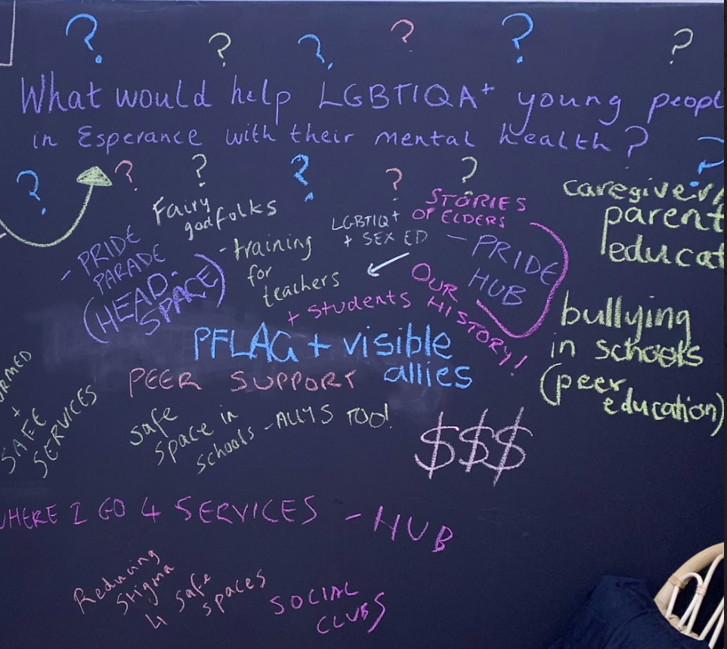

Solutions
This group of young people had the following solutions:
- Train all health, mental health and education staff in LGBTIQA+ inclusive practice
- Promote resources and groups that local young people can access
- Encourage local businesses and councils to publicly celebrate LGBTIQA awareness days (including IDAHOBIT, Pride Month, and Trans Day of Visibility)
- Set up and resource PFLAG to operate in regional communities to provide support and training for parents.
- Increase available funding for specific LGBTIQA+ projects in local areas through small grants.
- Train and support peers and peer hubs in schools and local area/community
- ‘Fairy GodFolks!’— a media campaign to share stories of local LGBTIQA+ elders and LGBTIQA+ success stories to challenge stigma and provide hope for young LGBTIQA+ individuals.

Engagement 4: Culturally and Linguistically Diverse Young People
Format: Online survey (10 responses)
Date: 4 November to 8 November 2021
Theme: Safe and inclusive services for CaLD communities
Overview: This engagement occurred via online survey to 2021 Catalyst Youth Summit attendees and organisers. Additional learnings from the September 2021 Catalyst Youth Summit were used and recommended for inclusion. The full Catalyst Report is available at www.yacwa.org.au.

Relevant Priorities
# | Action
8 | Diversity in the workforce - Review recruitment strategies to ensure the attraction and retention of a diverse workforce, including workers from Aboriginal, CaLD, and LGBTQIA+ communities.
10 | Prevention and promotion within CaLD communities - Identify new distribution channels in the CaLD community, for prevention and promotion materials.
16 | Department of Health (DoH) would like the young people engaged as part of the YPPA youth engagement activities to focus on providing input into how health services (particularly mental health/AOD) are inclusive and responsive to people from the LGBTQIA+ priority group. In particular, it would be useful to seek their input regarding what sort of staff training would be helpful, and ways services can be more inclusive. This aligns to various YPPA Top Priorities as well as various election commitments DoH have been tasked with
17 | Dep Local Government, Sport and Cultural Industries (DLGSC) would like young people to provide advice regarding how stigma, discrimination and racism can be addressed (relates to 1.8, 1.9, 4.12, 4.13).
19 | Dep Training and Workforce Development (DTWD) would like young people who are involved in TAFE to provide advice on what they expect TAFE and other relevant education/training providers to offer regarding supporting the mental health and wellbeing of young people (and reducing harm from AOD). How should these service be doing things differently to support young people?
7 | Peer workers - Fund youth peer support programs for LGBTQIA+ young people, young people from refugee and/or migrant backgrounds, Aboriginal young people, and young people living with disability.
17 | Dep Local Government, Sport and Cultural Industries (DLGSC) would like young people to provide advice regarding how stigma, discrimination and racism can be addressed (relates to 1.8, 1.9, 4.12, 4.13).

Overview
CaLD young people have unique needs and face unique barriers
- CaLD young people felt that understanding about mental health, alcohol and other drug use, and wellbeing was highly variable among communities. For some, stigma prevented them from speaking with their family or friends about these topics.
- CaLD young people felt they were often not represented within mainstream services. Many young people wanted to speak to someone from their own cultural background, which added extra barriers to accessing help compared to other young people.
- A lack of understanding of cultural issues and norms made it difficult for young people to form a relationship with service providers.
- Mental health awareness campaigns and service providers often do not advertise within CaLD community spheres, which often share information differently. A key example of this was during COVID, where mainstream communication methods were inappropriate for sharing health information and resulted in a lack of awareness.
Mental health education needs to be understanding of CaLD experiences
- Education should include peer facilitators and prioritise lived experience voices of people from CaLD backgrounds. Young people felt these voices were critical to ensuring information was relevant and provided from a place of authority.
- Inclusive education on mental health needs to address and respond to the unique experiences of young people from CaLD backgrounds. This should include:
- Understanding diverse cultural attitudes towards health and wellbeing
- Understanding of the impacts of racism and discrimination (both past and ongoing)
- Acknowledging different family structures among different cultures, and how this impacts available supports and responsibilities of young people from CaLD backgrounds.
Services are not inclusive for many CaLD young people
- Young people felt Western Australia needed more culturally appropriate and inclusive services, with many considering services un-inclusive by default.
- Creating culturally inclusive services requires partnerships with community leaders and trusted organisations. They wished to see services partner with their communities to take advice and improve their internal practices, alongside increasing awareness of the service.

Solutions
Solutions from this group of young people included:
- Increasing resources and funding towards advertising in culturally appropriate ways that are advised by community leaders and representatives.
- Mandating regular workforce training on CaLD cultural competency within mental health services
- Involving CaLD communities in decision-making processes. This may include ensuring CaLD young people are represented on Youth Advisory Groups in all services.
- Funding specialist youth services for CaLD youth.

Engagement 5: Family carers
Format: Online survey (11 respondents)
Date: 18 October to 8 November 2021
Theme: Support for the supporters
Overview: This survey canvassed the views and experiences of individuals caring for young people with mental health and/or alcohol and other drug challenges. The survey was promoted among consumer peak bodies representing carers. This included Carers WA, Consumers of Mental Health WA, the CARE Hub through the WA Association for Mental Health and the Mental Illness Fellowship of WA. An additional face-to-face interview was scheduled; however, this was unable to be completed within the consultation timeframe due to personal circumstances of the interviewee arising from their care responsibilities.

Relevant Priorities
# | Action
2 | Peer workers - Establish system navigation/youth workers and/or youth mentors in emergency departments to support people and smooth transition to community system.
4 | Culturally secure services - Invest in Aboriginal Community-Controlled Health Services (ACCHS) Social and Emotional Wellbeing programs, developed and led by Aboriginal people and their communities, across all regions of the state
13 | Integrated family and domestic violence (FDV) and mental health and AOD services - Strengthen FDV services through integrating, co-locating or embedding mental health and AOD workers
14 | Co-occurring mental health and AOD:  - Progressively review all relevant existing models of service and procurement processes so that co-occurring mental health and AOD issues are addressed by a single service or a consortium of services, or effective pathways between different services are established.  - Adopt processes and guidelines for addressing co-occurring mental health and AOD issues in an integrated way, learning from those that have been established and applied in other States and Territories.
12 | AOD transition support workers - Expand youth after hours, outreach and transitional AOD treatment and support services, supporting young people to transition between services.

Overview
Support for carers should be considered in services for young people
- Carers of young people indicated a diversity of challenges, wants, and needs associated with their roles in supporting young people experiencing MH or AOD difficulties.
- Carers wished to see greater education and information provided to carers, which would reduce their own levels of stress.
- Many carers felt burnt out by their caring responsibilities while navigating a stretched and underfunded system. Advocating for their care person’s needs was a daily struggle.
Services engaging with carers should prioritise non-judgement and listening
- Carers fundamentally wanted their voices heard and valued, and opportunities for them to tell their stories without being judged.
- Stigma and blame were considered common experiences that damage relationships and the wellbeing of carers.
- Suggestions for engagement included a trauma-informed approach, flexible timeframes to hear stories and develop trust between services and carers, and active information sharing.
- Services should design and promote avenues for carers to be heard in their service design.
Peer support can reduce isolation and shame among carers
- Carers felt support from other carers was a highly important opportunity, and would provide connection, reduce shame, and support good practice.
- Peer support for carers when accessing services such as Emergency Departments or inpatient settings should be explored.
- Carers wished for peer supports to be available for them when navigating services and complex decision-making around the young people they cared for.
- A number of pre-existing carer peer support programs were noted as providing good work, including Mental Illness Fellowship of WA (MIFWA), Helping Minds, the CARE Hub through the WA Association for Mental Health, and Consumers of Mental Health WA (CoMHWA).

Engagement 6: Eating Disorders
Format: Online survey (9 responses) and a one-on-one interview
Date: Survey: 18 October to 8 October 2021; Interview: 8 November 2021
Theme: Intersection of MH/AOD and eating disorders
Overview: The YSG felt eating disorders required specialised care and responses across the spectrum of intervention and identified discussions with those with lived experience as a priority for the additional engagements. This survey was promoted with the Butterfly Foundation, the YSG, metropolitan and regional summit participants, key community advocates, and researchers at Curtin University.

Relevant Priorities
# | Action
2 | Peer workers - Establish system navigation/youth workers and/or youth mentors in emergency departments to support people and smooth transition to community system.
3 | Specific training regarding supporting children and young people - Develop and provide relevant training in supporting and treating children and young people with mental health and AOD issues (e.g. school nurses, GPs, Mental Health Co Response, Emergency Department staff etc).
8 | Diversity in the workforce - Review recruitment strategies to ensure the attraction and retention of a diverse workforce, including workers from Aboriginal, CaLD, and LGBTQIA+ communities
11 | Evidence-based prevention activities in schools - Promote the following existing evidence-based prevention activities within schools:  - Response to Suicide and Self Harm in Schools Program  - School Drug Education Road Aware (SDERA)  - Aussie Optimism  - Teen Mental Health First Aid (MHFA) or other evidence based mental health literacy programs.
16 | Department of Health (DoH) would like the young people engaged as part of the YPPA youth engagement activities to focus on providing input into how health services (particularly mental health/AOD) are inclusive and responsive to people from the LGBTQIA+ priority group. In particular, it would be useful to seek their input regarding what sort of staff training would be helpful, and ways services can be more inclusive. This aligns to various YPPA Top Priorities as well as various election commitments DoH have been tasked with

Overview
Peer support is critical in eating disorder spaces
- In the absence of formal care, informal peer work arrangements are common. As a result, many were relying on loved ones (who may not be trained), other young people with eating disorders, and in some cases were making thing worse. There was a perception that unsupported peer work risks increased trauma and disconnection.
- Peer services should be supported to work within formal existing services, with appropriate training and frameworks to guide safe practice. Peer workers need to be valued, trained, paid, and accessible to be successful.
- Peer work would be beneficial at every step of eating disorder engagement, from prevention to serious crisis intervention. Fundamentally, this was about having people that are like you and know how to help.
Eating disorders supports need to be inclusive of LGBTIQA+ communities and neurodiversity
- For young people, meeting other people in their community with diversity of body types and expressions of gender was powerful and affirming. It was important not just to prioritise white, tall and thin bodies, but to see larger bodies, trans bodies, and bodies of diverse natures. This was important for inclusion and service engagement.
- Many LGBTIQA+ young people reported high co-morbidity of eating disorders and neurodivergence. Training and education on neurodivergence should be prioritised for LGBTIQA+ peer workers.
- The workforce is critical to inclusion, and services should actively recruit and support professionals who are peers—including psychologists and nutritionists. Representation within services was considered invaluable for ‘feeling seen’ and understood.
- For gender diverse young people, gender affirming care was a critical part of eating disorder responses. Gender affirming care in recovery was considered a recovery tool.
- Many young people avoid telling GP’s they are trans out of fear of discrimination, being denied care, or from not being able to advocate for their own needs.
Training for medical and mental health professionals specific to young people and eating disorders
- Youth eating disorder support practitioners need to understand gender and broader trans and gender diverse young people's needs.
- General medical professionals (such as GP’s) need specific training about commenting on body size and not entrenching beliefs about bodies. Many young people reported high levels of fatphobia from medical professionals that either worsened their symptoms or prevented them from seeking care.
- One young person indicated that some common processes in eating disorder treatment are not appropriate for gender diverse young people (such as mirror-based acceptance work) and need a specific model of treatment that services should understand.
LGBTIQA+ Inclusivity Training Needs in Services
- Young people felt this should include:
  - General ‘101’ information on LGBTIQA+ identities and issues (such as Opening Closets)
  - Understandings of trans bodies
  - Awareness of LGBTIQA+ specific community groups, supports, and services.
Schools can play a role in education and eating disorder support
- Young people said they would have liked education earlier in schools for themselves and helping friends
- Many schools reinforced gender narratives that did not allow for gender diverse young people.
- One young person commented that their eating disorder was highly connected to their misconceptions around gender, puberty, and social expectations. They felt education on gender diversity could have prevented their eating disorder from developing.
- Teachers should be supported to recognise, respond, and talk about eating disorders safely and non-judgementally. Teachers were in a unique positions as a first responder to eating disorders, which was considered the most important role in future help seeking.
“I’ve never seen someone look like me in services and advertisements...my body wasn’t shown, so I didn’t understand that it was normal.”

Engagement 7: First Nations
Format: Written interview
Date: 8 November 2021
Theme: Safe and inclusive services
Overview: Aboriginal and Torres Strait Islander young people participated in both the YSG and the two summits, however, the YSG felt it was critical that Aboriginal young people were provided dedicated opportunities to discuss their unique experiences and barriers to care. This interview was conducted with an Aboriginal young person represented on the YSG and supported by reflections from another Aboriginal YSG member. Additional interviews with other Aboriginal participants were scheduled but were unable to be completed due to personal circumstances of the interviewees. Further engagement with Aboriginal young people and communities is an essential component of future planning for the YPPA Implementation Plan, and community partnerships should be prioritised.
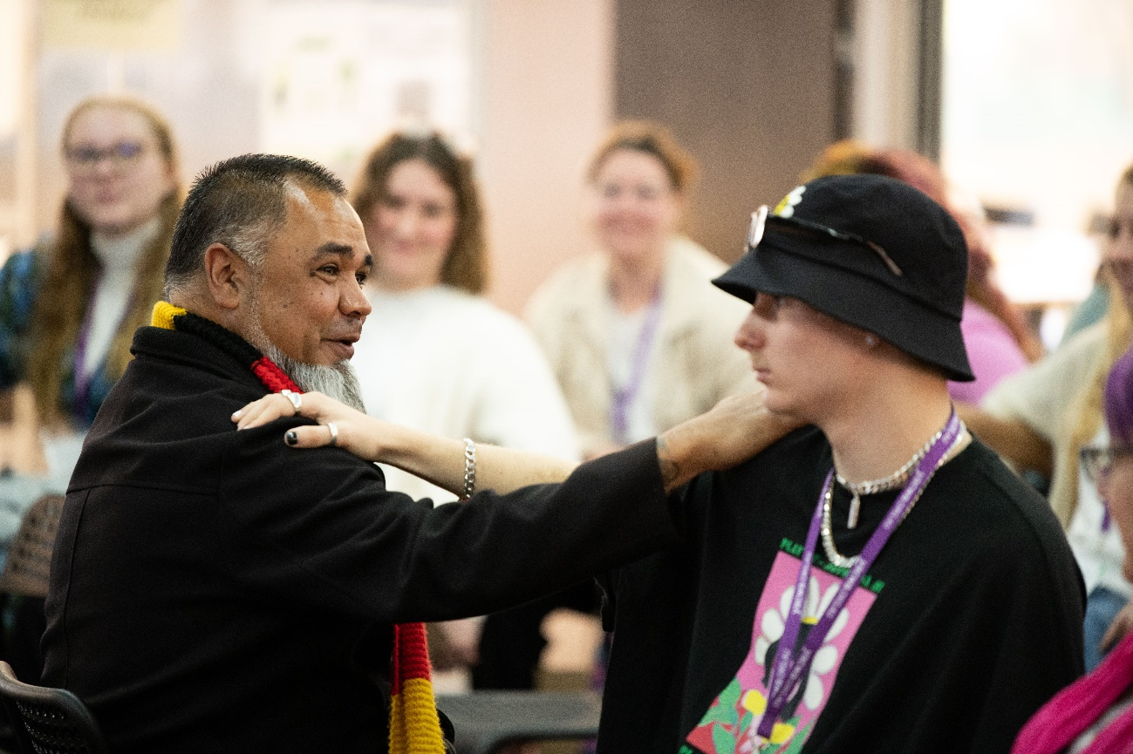

Relevant Priorities
# | Action
4 | Culturally secure services - Invest in Aboriginal Community-Controlled Health Services (ACCHS) Social and Emotional Wellbeing programs, developed and led by Aboriginal people and their communities, across all regions of the state
5 | Expanded state-wide campaigns and related community action in order to:  - Reduce alcohol related harm.  - Minimise the risk of harms relating to drug use.  Raise awareness of social and emotional wellbeing and the harms associated with AOD use among young Aboriginal people, their families and communities, such as through the Strong Mind, Strong Spirit metropolitan project.
7 | Peer workers - Fund youth peer support programs for LGBTQIA+ young people, young people from refugee and/or migrant backgrounds, Aboriginal young people, and young people living with disability
8 | Diversity in the workforce - Review recruitment strategies to ensure the attraction and retention of a diverse workforce, including workers from Aboriginal, CaLD, and LGBTQIA+ communities.
17 | Dep Local Government, Sport and Cultural Industries (DLGSC) would like young people to provide advice regarding how stigma, discrimination and racism can be addressed (relates to 1.8, 1.9, 4.12, 4.13).

Overview
The feedback below is provided verbatim from the YSG member to ensure their feedback is reflected appropriately.
Question: Thinking about social and emotional wellbeing programs, developed and led by Aboriginal people and their communities, across all regions of the state. What should this look like? Who needs to be involved?
Response: I personally believe that social and emotional wellbeing programs led and developed by Aboriginal people should present as a vast majority of indigenous people running these programs, which have been well trained and educated to perform their roles well to make the most effective and beneficial impact. There should be visible and trusted community leaders who call-in community. We should look at whatever is already being done in community and strengthen this by collaboration and resourcing. The main parties involved should be mental health organisations, and social programs such as sporting and recreation.
Question: How can stigma, discrimination and racism be addressed, especially in sport? What would help Local Government reduce discrimination in local sport and cultural events?
Response: This should be addressed by training the participants of sporting teams that this kind of behaviour isn’t going to be tolerated and is not appropriate. Also, adding harsher penalties for this kind of behaviour. Community and sports groups need education, as well as the wider community on especially the [subtler] ways that discrimination can look.
Question: How can peer support programs support young Aboriginal Mob to seek help for their mental health and wellbeing?
Response: Simply by unravelling this issue with their clients, then making referrals to the appropriate services. There needs to be community led and specific training for Aboriginal peer workers as well as culturally appropriate support for the duration of their role. Seeing Aboriginal peer role models in this space will make it easier for young people to seek help, especially if they can come to a peer first who can help them navigate the process
Question: What do First Nations young people need in order to want to work in mental health? What sorts of support do First Nations young people need to keep healthy and well themselves when they work in mental health?
Response: The need to want to work in this sector for indigenous people all comes from having the correct purpose of being in that role. There needs to be a clear understanding of your why, because over sometime a passion can be developed. Places of work in mental health need to understand and support the culturally diverse needs of their Aboriginal employees and understand the pressures that come with undertaking these roles (pressure from organisation to be the “Aboriginal Voice,” self-pressure [sic] to reflect our community well and pressure from Aboriginal community about working in this space. How we can keep ourselves healthy in these roles is by us living a healthy clean lifestyle and having people we can turn to for support ourselves, such as our team members or family and having a flexible workplace that understands the commitments we have to country, community and family.
Question: How can we raise awareness of social and emotional wellbeing and the harms associated with AOD use among young Aboriginal people, their families and communities, by using programs such as the Strong Mind, Strong Spirit program.
Response: I believe advocates should be employed by these programs that have walked through those life events and experiences. So, they can show that it can be done and can communicate to community what to expect.

Identified problems and challenges
The young person identified the following problems and challenges:
- Mental health and AOD Services are usually not informed about culturally appropriate ways of working with Aboriginal people
- Fundamental understandings about mental health and AOD and wellbeing are colonial and do not reflect an Aboriginal lens
- Workplaces do not support Aboriginal employees in a safe and inclusive way and there is immense pressure on Aboriginal employees to make their own work situation and their workplace better, rather than that pressure and commitment being on the employer
- Shame and stigmas has multiple other layers in Aboriginal contexts
- There is pressure to keep quiet about mental health, AOD and family and domestic violence because of how it reflects on the family and community

Solutions
- There should be peer connectors in all parts of the mental health recovery process. These peers need to be well trained and supported
- There should be specific suicide, mental health, FDV, AOD programs for Aboriginal people, by Aboriginal people
- All mental health projects should have Aboriginal reference groups, as well as input from Elders and Aboriginal champions to promote them to community
- Workplaces to have training and examine their culture and workplace structures and practices to ensure that Aboriginal employees are supported, and their voices heard.
- Mental health and AOD services to be trained in working with Aboriginal people and communities and to have Aboriginal employees throughout the levels of their organisation

Non-Negotiables
- Initiatives to be led by Aboriginal people
- Specific programs created by and for Aboriginal people
- Mental health and AOD services to have cultural competency training and understand other frameworks for recovery
- Flexibility and resourcing that understands the complexity of working in community

Engagement 8: Regional Young People (Goldfields)
Format: Individual conversation
Date: 4 November 2021
Theme: Regional reflections
Overview: This survey was completed by a leading clinician at Headspace Kalgoorlie. The clinician prepared for the survey by holding individual meetings with key staff across the survey who provided their insights and observed trends in the Goldfields region.

Relevant Priorities
# | Action
1 | Young people working in the mental health and AOD sector - Develop and promote pathways to encourage young people to work in the mental health and AOD sector, including in prevention and peer work.
2 | Peer workers - Establish system navigation/youth workers and/or youth mentors in emergency departments to support people and smooth transition to community system.
3 | Specific training regarding supporting children and young people - Develop and provide relevant training in supporting and treating children and young people with mental health and AOD issues (e.g. school nurses, GPs, Mental Health Co Response, Emergency Department staff etc).
4 | Culturally secure services - Invest in Aboriginal Community-Controlled Health Services (ACCHS) Social and Emotional Wellbeing programs, developed and led by Aboriginal people and their communities, across all regions of the state.
7 | Peer workers - Fund youth peer support programs for LGBTQIA+ young people, young people from refugee and/or migrant backgrounds, Aboriginal young people, and young people living with disability.
8 | Diversity in the workforce - Review recruitment strategies to ensure the attraction and retention of a diverse workforce, including workers from Aboriginal, CaLD, and LGBTQIA+ communities.
9 | Mentally healthy workplaces - Implement the Thrive at Work program across Western Australian industry.
17 | Dep Local Government, Sport and Cultural Industries (DLGSC) would like young people to provide advice regarding how stigma, discrimination and racism can be addressed (relates to 1.8, 1.9, 4.12, 4.13).

Overview
Stigma around mental health continues to impact access
- There is still a massive stigma about mental health that prevents young people from accessing services. Headspace is known as HeadCASE! There needs to be more mental health engagement where young people are, such as school, sport, skate park, events etc.
A lack of regional crisis services can contribute to service disengagement
- There are no crisis services in town so young people are worried about help seeking. They are concerned that they will be taken to Perth and away from their loved ones and support systems, and that also the whole town will know about it. This is a barrier to seeking support, especially if family don’t want them to go, as they may have family responsibilities or care for younger children, etc.
- Having peers supporting them when up have to go to Perth would be so powerful, also in hospitals
- Young people need a hub where they can access all different types of services at one time, including mental health, AOD, family and domestic violence, eating disorders, health, sexual health etc
- Families involved with other agencies such as Child Protection can prevent young people from accessing services as they are worried it may draw attention to them or call into question that they are responsible for their child's mental health.

Engagement 9: Young People with Disability
Format: Online survey (1 response)
Date: 7 November 2021
Theme: Accessibility and Inclusion of young people with disability
Overview: This engagement was conducted with deafblind advocate, Vanessa Vlajkovic. Vanessa was selected to attend the metropolitan summit, however a shortage of available deafblind interpreters prevented her from attending. Vanessa requested this engagement occur via online survey after further difficulties engaging an interpreter for in-person conversation.

Relevant Priorities
# | Action
7 | Peer workers - Fund youth peer support programs for LGBTQIA+ young people, young people from refugee and/or migrant backgrounds, Aboriginal young people, and young people living with disability.
8 | Diversity in the workforce - Review recruitment strategies to ensure the attraction and retention of a diverse workforce, including workers from Aboriginal, CaLD, and LGBTQIA+ communities.
11 | Evidence-based prevention activities in schools - Promote the following existing evidence-based prevention activities within schools:  - Response to Suicide and Self Harm in Schools Program  - School Drug Education Road Aware (SDERA)  - Aussie Optimism  Teen Mental Health First Aid (MHFA) or other evidence based mental health literacy programs.
17 | The Department of Local Government, Sport and Cultural Industries would like young people to provide advice regarding how stigma, discrimination and racism can be addressed (relates to 1.8, 1.9, 4.12, 4.13).

Overview
Supporting disability inclusion in mental health and AOD education
- The young person valued first-hand stories and lived experience in education. Ideally, this would include a diversity of speakers which included young people with a disability sharing their stories as part of education.
Peer support
- Peer reviews and word-of-mouth was the most important aspect of service referral for the young person, followed by using the internet
- Supporting peer education and workers in schools, university, and TAFE was also valued.
The mental health and AOD sectors need greater accessibility training
- The young person felt there was very little understanding of disability among service providers which made access very difficult and onerous for young people with a disability.
- They felt current accessibility relied on individual workers and was not supported at a policy or whole-of-system level.
- Many young people are unable to or reluctant to access services in person due to the burden of managing their own access needs and care.
- They wished to see services manage access and care pro-actively, such as providing interpreters for young people, actively posting accessibility conditions of buildings and sites, and reviewing the accessibility of their service through consumer groups.
- Young people living with a disability are highly affected by service fees and costs. Financial accessibility and physical accessibility need to be considered hand-in-hand.

Evaluation and next steps

Youth Steering Group Reflections
The Youth Steering Group (YSG) was considered a highly valuable opportunity for the members, who felt the role had helped them grow as human beings, professionals, and as members of their communities. A number of positives and challenges emerged throughout the project that can be applied to future engagement activities with young people.

Positives
Actively participating in improving the mental health and AOD systems was a powerful protective factor for mental health and gave members of the YSG hope for a better way forward. They wished to see true co-design continue into the implementation of the YPPA.
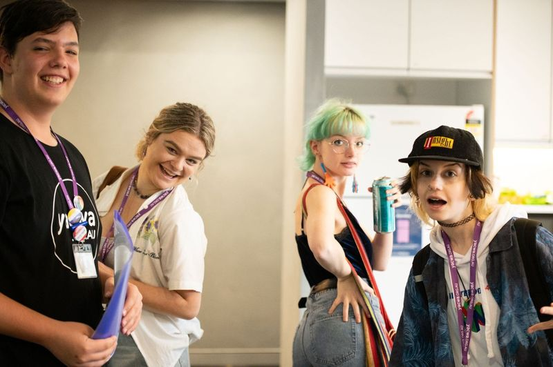
“It is beyond rewarding knowing I am contributing to a project that will improve the wellbeing of young people in WA”
“We all spent countless hours to make the events the best they could be from organising them, running them and designing them, such a meticulous task that was so rewarding, I can't tell you how many times I looked over a design or the wording to make it absolutely perfect. But the conversations from young people, from those who were the best bit of this project, an inspiration to me and their peers to be able to speak their truth and make change would have been nothing short of a revelation to me before this project.”
The opportunities to access free professional development training through Connection and Wellbeing Australia were highly valuable. The members felt they improved the quality of the project as well as developed their skills.
Three YSG members requested project staff to be references for job applications throughout the project, feeling they were more employable and valuable as a result of their learnings.
Many members expressed interest in working in mental health or alcohol and other drugs support or community services as a result of their participation.
“To think that I, a young person who has experienced the mental health systems, who has experienced hardships, who had experienced a loss of hope would then put their hand up and just go for it, still blows my mind, in the best possible way. We have such an amazing opportunity for young people like us to have our voices heard and take part in creating an amazing mental health system. Improving mental health treatment for all Australian youth is now something off my bucket list but not out of my mind!”

Challenges
There were difficulties in both being young people with lived experience and facilitating conversations and spaces for other young people at the same time. The YSG felt this hampered their abilities to contribute their own experiences (sometimes wondering if it was appropriate), as well as was potentially triggering. A significant amount of work and support was done to assist the YSG to learn how to hold this space.
The challenges of life impacted some members ability to remain engaged throughout the project. Relationship breakdowns, the loss of loved ones (and associated sorry business), and personal challenges all continued throughout the project.
The YSG felt the project could have benefited from additional time and resources. This was particularly to support:
- More in-depth hackathon planning at the metropolitan and regional summits
- Face-to-face regional events across the State, acknowledging that online events were not a substitute for in-person connections
- Supporting greater safety mechanisms for young people
- Allowing additional time to engage other young voices
“In retrospect, there was more we could have done to make the summit a safer space for all young people—many young people were quite anxious during the first morning.”
The list of priorities from the MHC was provided late in the project, just over three weeks away from the metropolitan summit’s date. This hamstrung planning processes and created a significant time crunch for the YSG members and project staff. Despite these time constraints, the project was still able to deliver events which resulted in critical information and insights that in turn supported the development of the of the YPPA implementation plan.
“We did not have the list of priorities finalised before the applications went live. We had to select young people based on whether we thought their stories matched some of the priorities and allocate them to groups based on our perception of their interests/knowledge/capacities. If they were finalised beforehand, young people could have allocated themselves to groups based on their interests/knowledge/capacities—this would have made the selection process far easier and perhaps young people would have been happier with their groups on the day.”

Voices Requiring Further Engagement
The YSG wished to see some voices further engaged throughout the project provide additional insights and opportunities to contribute to the YPPA’s implementation planning. They felt these voices had unique perspectives that should be explored in detail and dedicated forums but were unable to be captured appropriately due to time and resourcing constraints. These included:
- The intersection of mental health and climate change (‘climate anxiety’)
- Dedicated Aboriginal and Torres Strait Islander engagement mechanisms
- Culturally and Linguistically Diverse communities, acknowledging the diversity within this broad umbrella term.
- More diverse voices of young people living with a disability, including acquired and congenital disabilities, developmental disabilities, and carers of individuals with disability.
- All regional areas across Western Australia through face-to-face engagements.
Some voices were considered vital to the project, but were unable to be captured (again, due to time or resourcing constraints). These were:
- Young people currently experiencing homelessness or housing instability
- Children of veterans
- Young people in out-of-home-care
- Young people in the justice system (including both within detention and on Community Based Orders).

Appendix A: Engagement Strategy
Purpose
To inform the implementation of the Young People's Mental Health and Alcohol and Other Drug Use: Priorities for Action 2020-2025 by supporting and guiding the Youth Steering Group to design implementation strategies and recommendations of top 20 priorities from the YPPA.
This YSG will be supported to engage with young people, their families, and carers, to determine how the State Government should accomplish these 20 priorities.
Consultation audience
Young people aged 15 to 25 who have lived experience of MH and AOD, their families and carers
Consultation deliverables
The following deliverables will be led by the consultant, in collaboration with YACWA:
- Leading a youth steering group of up to 10 young people to co-design and co deliver the project from beginning to end.
- Delivering a one day (5 hour) virtual event/hackathon for young people from regional and remote areas
- Delivering a two-day youth mental health event focused on co-designing priorities pre identified from the Priorities for Action 2020-2025 plan.
- Supporting the participation of up to 30 young people from a diversity of backgrounds and experiences across the mental health and AOD sectors in both the virtual event and in person event (60 young people total).
- Delivering up to 10 instances of youth engagement on priorities that focus on one cohort or location (i.e. focus groups, one on one interviews or surveys).
Consultation process
The consultation is to commence on 7 July 2021 and must be completed by 31 October 2021. CAWA will deliver the follow schedule of services:
Phase | Timeframe | Service description
Planning | Ongoing | - Support the selection of Youth Steering Group (YSG) members  - Hold meetings with funder (MHC) – fortnightly, moving to monthly and the Youth Mental Health Subnetwork (as required)  - Regular project check in’s with YACWA  - Develop a risk management and mitigation plan
Summits and other engagement planning | July to September 2021 | - Hold regular meetings with the YSG to co-design the program and key elements including:  - Work with MHC on the prioritisation framework (in collaboration with YACWA)  - Identify guest speakers  Identify MC and person to run the Hackathon  - Identify key touch points in the summit for the MHC, Senior Officers Working Group, and other key stakeholders  - Develop and design the program  - Develop a run sheet / MC notes etc.  - Develop interview questions, survey, or other focus group activities for other engagements  - The number of planning meetings with the YSG will be approx.10 (of three-hour duration), but the YSG will be supported to co-facilitate the online and in person summits and engage in other elements depending on skills and interest (i.e., design promotion material, assist with presentations to key stakeholder groups, assist with the 10 unique engagements etc.).
Summit delegate management | July to October 2021 | - In collaboration with YACWA:  - Develop a criteria and ‘ways’ of recruiting young people to ensure diversity of background and experience (i.e., organisational nomination, self-nomination, or a mix)  - Build connections with metro and regional organisations to nominate young people  - Roll out application / nomination process  - Select delegates
Communications and promotions | July to September 2021 | - Engage with services and key stakeholders (both summit and other engagements)  - In collaboration with YACWA:  - Develop promotional material (potentially supporting the YSG to do this)
People and personnel | July to September 2021 | - Support and train the Youth Steering Group to facilitate table discussions at the summit and assist with interviews or focus groups  - Brief and debrief with staff and young people around all elements of the project  - In collaboration with YACWA:  - Identify staffing needs for events  - Identify and book attendance of key stakeholders for the summit
Summit | September to October 2021 | - Confirm delegates, catering, venue requirements, COVID requirements, MC, photographer, and all presenters  - Set up virtual event (including platform, tools etc.)  - Host virtual event (September)  - Host in person event (October)
Other engagements | July to September 2021 | - Work with external organisations to arrange one on one interviews, focus groups and surveys) both YACWA delivered, and service led
Report and follow up | October 2021 | - Contribute data to the final report

Consultation guiding
The consultation will guide the YSG to explore the 20 top priorities as defined by the group and their engagement with other young people. Guiding questions will focus the work of the YSG to look at what is doable, achievable and what will have most impact for young people and their experiences of mental health and alcohol and other drugs
Approach and engagement principles

Empowering and flexible
Young people will be allowed to make choices regarding how they engage in the consultation process to meet their needs and level of comfort. This includes providing them choices to contribute as an individual or in group conversations, and in how their conversations will be documented.

Safe environments
To ensure young people are comfortable, consultation will take place in environments familiar to the young person and/or that they are comfortable being in. Environments will meet all access needs including gender neutral bathroom facilities.

Safe spaces
Group space guidelines will be developed to ensure that spaces of engagement are safe and inclusive spaces that respect the intersectional diversity of all young people.

Cultural security
The engagement process will be individualized, and value the agency, experiences, and comfort of all young people.
Prior to employment and upon employment, young people in the YSG will be provided opportunities to discuss any needs related to maintaining a culturally secure space. Questions around cultural background will not be asked of the young person directly to ensure they do not have to undertake cultural labour they don’t wish to. Questions will be closely focused on service and sector experience; however the interviews’ informal nature will allow discussions on cultural backgrounds and issues to occur at the young person’s discretion.
An intersectional approach will be used to guide the work of the YSG and ensure that safe an inclusive spaces are created for young people to participate.

Access and participation
The engagement process will ensure that a variety of communication and activity approaches are used to reflect the diversity of communication styles and needs of the young people. Participation will be made available in a variety of settings and facilitators will ensure that group dynamics are managed to ensure all members of YSG are supported to participate as they wish.

Respectful and informed
Young people will be provided with information and context as to the consultation process and how their information will be used, as appropriate. Young people will be reimbursed for their time and contributions appropriately.
Young people will be provided with a draft copy of the report at the end of the project to see how their experiences have been represented, as well as an opportunity to review and provide further feedback.

Giving and receiving feedback
Mechanisms will be developed that enable the young people and YACWA staff to give real time feedback in a variety of ways. We will observe a culture that values respectful feedback.

Avoiding tokenism
The project will promote a safe and supportive culture that celebrates young people being genuine partners in decision-making. All engagements will recognize the complexity and diversity that exists in all communities and strive to involve a range of voices. This will include respectful recognition of the unique needs and challenges faced by specific communities across WA.

Safety mechanisms and duty of care
Risk or issue | Mitigation strategies | Proponent
Staff have the appropriate legal qualifications to work with young people | - All involved facilitators have a current National Police Clearance  - All involved facilitators have a Working with Children Check. | YACWA
Young people feel intimidated by the consultation process. | Initial engagement to set tone of empowerment:  - Consultation is peer-led  - Informal discussion-style consultation  - Young people are approached via a service provider they have an existing  - relationship with  - Consultation will take place in a familiar venue to the young person (i.e. service  - provider’s location)  - Qualified support person at every engagement  - Consultants and staff are experienced working with young people | CAWA  YACWA
Young people feel constrained by the process | Young people are offered choice and flexibility in the consultation:  - Choice to participate as an individual or with others as a group  - Flexibility in options of how young people can participate  - Informed choice of how consultation is recorded (audio recording, note taking etc)  - YSG will be offered value adds in the form of Learning and Development opportunities that can build their capacity to undertake further advocacy and employment | CAWA
Young people experience  difficulties or re-traumatisation  from engagement | - Young people with appropriate supports and stability are approached for participation and asked about existing support relationships  - Referees asked specifically about young people’s current capacity and support access  - Qualified support people at every engagement  - Young people are provided context to the nature of engagement prior to employment  - Young people are informed of available supports at the end of each engagement  - Young people provided with support information, EAP access and self-care kits upon employment  - Young people will be encouraged to share the learnings from their experiences, rather than the experiences themselves  - Standard check-in and check-out processes have been built into all meetings and engagements | CAWA  YACWA
Young people must consent to the consultation project | - Young people are provided a consent form outlining context and scope of engagement and how their information will be used.  - Young people under the age of 18 must receive permission to participate from them  - parents/guardians.  - Parent/guardian permission slips are provided outlining the consultation  - process and how their child’s information will be used.  - Verbal consent will be accepted if necessary, from parents with difficulty completing permission forms.  - Young people in out of home care may have their permission form signed by their Child Protection Worker.  - Young people and their guardians are aware they can withdrawal consent at any time | YACWA
Young people experience conflict | - Feedback loops will be established and clearly explained to young people providing them avenues to voice their concerns safely.  - Young people will be advised of appropriate communication pathways for issues. | CAWA  YACWA
Communication and boundaries | - YSG meetings were established with communications pathways and processes as agreed upon by the group  - YSG meetings established firm boundaries around contact between YSG staff during and outside of work  - Feedback and Complaints mechanism created for YSG members to discuss any concerns | CAWA  YACWA
Safety of young people under 18 | - Child safety principles and all YACWA policies will be adhered to  - YSG members and YACWA/CAWA staff will not be alone with underage YSG members or young people unless another adult is present | CAWA  YACWA
COVID restrictions interrupt or delay delivery | - YSG meeting agenda item to discuss alternate engagement strategies if restrictions are implemented. Youth friendly, interactive online options such as Gather https://gather.town/app will be used in place of face to face events.  - Existing network of YSG members, YACWA and CAWA can be engaged to support alternate engagement strategies in their own communities  - CAWA and YACWA to keep MHC updated on current status of outputs throughout the project and immediately raise any concerns about timelines that are affected by any returning COVID restrictions | CAWA  YACWA
Young people disengage or opt out from the process due to concerns about cultural safety | - YSG members were chosen from diverse backgrounds  - YSG members will be encouraged to support involvement from their own peer communities  - Cultural safety requirements have been built into YSG EOI process, referee checks, meeting processes and group guidelines  - YSG members and external stakeholders with intersectional identities will be seen as the experts of what young people from their communities need to feel that the events are safe and inclusive  - Communications will be developed with diversity in mind | CAWA
Young people will have barriers to participation due to their accessibility needs | - Access and inclusion needs will be standard questions of all EOI, survey, registration etc  - Budget will be used to prioritise participant needs such as interpreters, support staff, transport, childcare etc.  - Venues selected will be accessible and have gender neutral bathroom options | CAWA
Regional/rural/remote young people are limited in their participation due to engagement being online only | - Alternate consultation processes (phone etc) will be offered  - IT and internet access options will be explored with local councils, schools, and mental health/AOD services for regionally based young people to access to enable their participation  - CAWA, YACWA and YSG will use their existing regional networks to find local solutions for communities  - CAWA will use travel that has been planned for other projects as a way to undertake in-place engagements | CAWA

Appendix B: Metropolitan summit run sheet
Day 1 schedule
Time | Activity
7:30am | Set-up
8:25am | Staff briefing
9:00am | - Participants arrive  - Registration
9:30am | - Opening welcome by MC  - Welcome to Country  - Welcome by Sandy from YACWA  - Housekeeping by MC
10:00am | Space setting and guidelines
10:45am | Morning tea break
11:00am | Hackathon training activity  - Introduction by Bella  - Introduction to elevator pitch activity by Elizabeth  - Group work time  - Pitching time
11:50am | Part 1: Introductions  - Re-introduce the priorities and YACWA group leaders  - Explain first activity and split into groups; introduce YACWA staff members  - Photo activity  - In their teams, participants choose a photo to use as a prompt to share either:  - A change they want to support/see to the MH & AOD system  - Their ‘why’ for attending the forum  - The strengths/perspective they bring to the table today in the co-design process  - Network mapping and introducing the priority for the group  - YACWA staff/YSG members share the priority/challenge the group will be working on, explaining the scope/answering any questions the group might have about the challenge.  - YACWA staff/YSG member share map of the strengths/POVs in their group; facilitate discussion in the group on the following questions:  - Which voices, perspectives or people are not represented in our team today, but should be considered when developing solutions?  - Which stakeholders or other organisations do we know who influence this space/challenge?
12:30pm | Lunch break
1:15pm | Part 2: User journey  - Building the persona  - Identifying key challenges, experiences, needs of young people in the system in one persona as a group  - Mapping their journey  - Three parallel brainstorms:  - Current journey (identifying the touchpoints that most young people have with the system; rate their efficacy)  - Available journey (what services/support exists but isn’t accessed by young people, and why?)  - Parking lot (to ‘park’ ideas/potential solutions that arise throughout the course of discussions)  - Identifying opportunities for change  - Everyone has the opportunity to vote for their top 2 opportunities for change/to work on in their presentation later with stickers  - Finalise list of top 3-5 opportunities for change or intervention in the system
1:40pm | PART 3 – The system  - Validation interviews  - Arrange chairs in a circle set-up  - YSG member introduces the “guest” (YACWA STAFF) using their biography, asks them the pre-set questions  - Gives the group a couple of mins to produce further questions with a partner  - YP ask questions  - Group debriefs  - Under the ‘user journey’ brainstorm, add a third brainstorm, the system journey.  - As a group, debrief on the ideas/perspectives shared by the guest to map out some of the operational barriers, insights or questions gained from the interviews.
2:15pm | Afternoon tea!
2:30pm | Part 4: Solutions  - Introduction to solutions exercise  - Groups reconvene to main area; afternoon tea brought out to grab and sit down  - Ideation process  - Pitching/presentation expectations for day 2  - Accessing slide deck templates etc.  - Ideation  - Silent brainstorm  - Group brainstorm  - Sort ideas into impact vs. effort matrix  - Team work on presentations  - Continue working on presentations with the template for tomorrow
3:40pm | Debrief and close  - Overview of agenda for day 2  - Helping participants to check out after the session and to leave the ideas, experiences and stories shared in this space
4:00pm | Close
4:00-5pm | Pack up
5pm - 5:30pm | Staff debrief and planning for tomorrow
Day 2 schedule
Time | Activity
7:30am | Set-up
8:35am | Staff briefing
8:45am | - Participants and stakeholders arrive  - Sign in
9:05am | Day 2 begins  - MC acknowledgement of Country
9:15am | Commissioner speaks
9:25am | Stakeholder briefing  - Stakeholders remain in main space to be briefed on their role, learn more about the co-design process & expectations of the day  - Delegates break off into their groups to have time to prepare and finalise their solutions & presentations
9:55am | Transition  - Reconvene as a whole group, set-up first presentation slides on the projector
10:00am | Presentations - Part 1  - Presentations to be delivered by young people to stakeholders.
10:40am | Morning tea break
10:55am | Presentations - Part 2  - Presentations to be delivered by young people to stakeholders.
11:35am | Stakeholder discussions  - Introduce activity  - Find and break into smaller groups  - General reflection and feedback from stakeholders/discussion about the presentation, opportunity to ask further questions for clarification  - YACWA/YSG member facilitates discussion on ‘next steps’ for the solutions and ideas presented; collaboratively, delegates & stakeholders brainstorm and discuss solutions and further ideas for:  - Solution, non-negotiables, what it shouldn’t look like  - Delivery, commissioning  - Outcomes, measuring success  - Groups can choose to break into smaller groups with different stakeholders first to discuss different components (i.e. one group tackles delivery/commissioning, one group tackles impact and outcomes).  - Smaller groups reconvene with their teams to share ideas discussed, offer constructive feedback.
12:30pm | Lunch
1:15pm | Design challenge  - Introduce and explain activity  - How can young people be part of the ongoing feedback/contribution to ensure its constantly updated to reflect best practice & the changing needs of young people?  Group working time  - Split into smaller groups and collaboratively develop solutions and ideas.  Presentation of ideas and solutions  - Each team presents for maximum of five mins
2:25pm | Afternoon tea
2:50pm | Team Reflection & Debrief  - Break into smaller groups again  - Reflection and debrief on the final presentations, solutions; add any further questions or opportunities for research  - Each person reflects on a highlight from the Summit, and a change they still want to see/what was missing  - Debrief  Whole group debrief and next steps  Reconvene to main group  - Debrief and next steps beyond the summit  Thank you and close
4:00pm | Day 2 ends
4:00-5pm | Pack up
5pm | Staff debrief

Appendix C: Facilitators guide

About the Hackathon
The Hackathon will be focused on four challenges which we have developed from top priorities identified by the Mental Health Commission (MHC) and Youth Steering Group (YSG). We’ve framed the priorities as “how might we…” challenges, which will encourage participants to be solution oriented. The aim of the Hackathon on day 1, is for each group of participants to have worked through a co-design framework to develop solutions that meet the needs of the young people in the system, as well as considering the logistical and operational barriers of the system itself. On Day 2, each group will present their solutions in a pitch/presentation form, a maximum of 10 minutes each, to stakeholders in the MH & AOD sectors.

About Your Group
One YACWA staff member will be allocated to each challenge, to be the lead facilitator of that group. We will allocate participants to groups before the summit, they will not be choosing their groups. Your group will be of approximately 7-8 young people, some of whom may have lived experiences with the services/priorities your group is focusing on, but this will not necessarily be the case for every member of your group.
For the afternoon on Day 1, most of the session will be facilitated by yourself, in your groups. This means that it is important that you understand the challenge that your group has been allocated, its scope, as well as the general overview of the afternoon. It will be your responsibility to manage your time and to keep your group on track to reach a conclusion/solution at the end of the day. See the background and supporting information for each challenge here.
You will have at least one other YACWA staff member, as well as at least one member of the YSG to support the facilitation and activities.

Key responsibilities
- Keep track of time. There is a lot to get through during the day. Given the weight and experiences of participants with the topics being discussed, it is natural to expect that at times we will diverge from the planned timing. However, wherever possible, your job is to make sure that you are mitigating this with being able to reach a set of solutions with your team at the end of the day, and not being weighed down by the seriousness of the topics, rather orienting your teams’ discussions towards solutions and change.

- Capture information discussed, written and created. At least one of the supporting facilitators/staff members for your group should be tasked with typing up the discussions (to the best of their ability) as well as photographing the brainstorms and ideas developed. I have created a Google Drive folder here, which will have all the worksheets for each section of the day. Find the folder allocated to your team, and make sure that someone from your team is capturing the information as you progress throughout the day in the Google Docs provided.

- Understand the scope of your challenge and the priorities behind it. To ensure that your team stays relatively on track, and that you can help them to focus. These are huge systemic and complicated problems, as you are aware, so the purpose of the challenges is to help the groups to create more specific and impactful solutions. The Summits are only one part of broader engagements/consultations being conducted for this project. It’s okay to not cover ‘everything’ related to your challenge on the day, as particularly in the case of addressing experiences of different youth demographics, this may be covered in its own separate consultation beyond the summit.

- Be cool. This is a BIG day. BIG topics. BIG ideas. And BIG aspirations for how much we can achieve in this time. Help your group to stay cool by staying cool yourself! At the end of the day, the purpose of this summit is to give young people a meaningful vehicle to develop their opinions and share their ideas for a better future. The rest is secondary.

- Check in and Out: As you start each section ask “How are we all doing? Is there anything anyone needs to get on the table to be able to concentrate and focus for the next few hours?” As you end each section ask How are we all doing? Is there anything anyone needs to leave on the table to be able as we finish this section and/or head to the break?.”

Ask each of your group to let you know if they are leaving for any reason. If any of your group members leave, please let Bella and the Support Staff know so they can follow up

Part 1 - Introduction
Hackathon Kick-Off
- Re-introduce the priorities & YACWA group leaders
Be ready to give a brief 1-2 minute introduction to your challenge statement to the entire group of attendees.

Team Building
- Explains first activity and split into groups; introduce YACWA staff members
Briefly introduce yourselves and other staff in your group and reinforce that your group is a safe space for participants to share their ideas and views, and that they are able to leave the space whenever they need to, to access support or just to take a break.

Photo Activity
- In their teams, each participant chooses a photo to use as a prompt to share either:
- A change they want to support/see to the MH & AOD system
- OR their ‘why’ for attending the forum
- The strengths/perspective they bring to the table today in the co-design process
From here, you will be in your small groups for the majority of the afternoon. The photo card activity is a good way to allow participants to express however much they are comfortable sharing, as well as building trust in the group (by introducing each other in a more meaningful way rather than i.e. I go this school / I work here). If some participants do share something very personal/vulnerable, make sure to acknowledge/thank them for sharing.

Network mapping & introducing the priority for the group
- YACWA staff/YSG members share the priority/challenge the group will be working on, explaining the scope/answering any questions the group might have about the challenge.
See the briefing notes for your challenge, please ask any questions to clarify the scope/focus beforehand.
- YACWA staff/YSG member discuss strengths/POVs in their group; facilitate discussion in the group on the following questions:
- Which voices, perspectives or people are not represented in our team today, but should be considered when developing solutions?
- Which stakeholders or other organisations do we know who influence this space/challenge?

Part 2 – User journey
Building the Persona
- Identifying key challenges, experiences, needs of young people in the system in one persona as a group
The purpose of this activity is to build a more detailed profile of a young person experiencing the target challenge, considering their needs, problems, and hopes/goals.

As a group, allow participants to brainstorm ideas.

The ‘persona’ will also be a tool to hold space for the lived experiences of participants, without forcing them to share their own stories (rather, they can project them onto the persona).

* Note * often groups begin to diverge and talk about solutions/systemic challenges here, which is great. Try to bring the discussion back to building a persona profile and capturing the needs of young people (rather than ideas of how to meet them) because the other topics will be addressed as we go.

[Mapping their Journey
- Three parallel brainstorms:
- Current journey (identifying the touchpoints that most young people have with the system; rate their efficacy)
- Available journey (what services/support exists but isn’t accessed by young people, and why?)
- Parking lot (to ‘park’ ideas/potential solutions that arise throughout the course of discussions)
The purpose of this activity is to map the current journey of the persona in the system relevant to your challenge. See accompanying diagram here for how the room will be set up. The current journey entails the typical experiences and touchpoints that the persona has with the system right now.

Below this, the participants will map the available journey for their persona, which entails the existing services, solutions and support that exist to try and respond to this problem, but for some reason or another are not used/typically engaged with by young people. Challenge your group to consider why this is - what barriers block the persona from taking up the existing support services?

* Note * at this point, groups will often start generating ideas/solutions. Again, this is GREAT, but not the focus of this activity; to help with this, each team will have an A3 parking lot page, where throughout the day, participants can ‘park’ questions, ideas, further discussion points to come back to later.

Identifying opportunities for change
- Spend 1-2 minutes grouping the sticky notes together into like/similar categories.
- Everyone has the opportunity to vote for their top 2 opportunities for change/to work on in their presentation later with stickers
- Finalise list of top 3-5 opportunities for change or intervention in the system

After your brainstorm of the persona’s journeys, every participant has the opportunity to vote (with coloured dot stickers) on their top 2 opportunities for change or intervention in the system.

This will inform which part of the system/persona journey your group focuses on later to develop a solution for.

At the end of the activity, summarise the top 3-5 opportunities for change/intervention agreed on by your group.

Part 3 - Validation
Validation interviews with Stakeholders/Subject Matter Experts
The purpose of this activity is to support the participants in understanding the perspective of the ‘system,’ or stakeholders working in it trying to support young people already.

ach group will have a subject matter expert/stakeholder join their team for half an hour, who will be briefly interviewed by either yourself, support staff or YSG member.

The goal of the conversation is to help participants to understand:
- The experiences of stakeholders in the system
- The logistical challenges or operational barriers they face
- Which types of solutions/services have worked, from their perspective
- What they need or look for in solutions

You can see sample questions to ask the stakeholder here.

This can help participants before they go into the final activity of designing solutions, to design solutions that are more likely to be supported by the system, as well as to learn from their mistakes, and prepare them for empathising with/understanding the perspective of the stakeholders who they will meet on Day 2 of the summit.
- Arrange chairs in a circle set-up
- YSG member introduces the guest using their biography, asks them the pre-set questions
- Give the group a couple of mins to produce further questions with a partner
- Young people ask questions
- Guest leaves

Group debriefs
- Under the ‘user journey’ brainstorm, add a third brainstorm, the system journey.
- As a group, debrief on the ideas/perspectives shared by the guest to map out some of the operational barriers, insights or questions gained from the interviews.

After the subject matter expert/stakeholder interview, regroup with your team, to reflect on what they learnt from the interview, and as a group add new ideas/perspectives/insights gained from the conversation to each relevant step of the persona journey, to consider as they are developing solutions.

Part 4 - Solution
Introduction to solutions exercise
- Groups reconvene to main area; afternoon tea brought out to grab and sit down
- Ideation process
- Pitching/presentation expectations for day 2
- Accessing slide deck templates etc.

Elizabeth will explain this with all the groups at once. We have created a slide deck template for participants to use, see here.

There will be a laptop available (from YACWA) per team, which the groups can use to develop short pitch decks capturing their ideas and solutions. They will then present these on Day 2 of the summit to the stakeholders.

Ideation
- Silent brainstorm
- Group brainstorm
- Sort ideas into impact vs. effort matrix

Finally! This is the opportunity for teams to work on creating solutions and designing the ideal system or persona journey for their persona.

Best practice for ideation:
- Allow some time for a silent brainstorm where everyone can add their ideas to sticky notes, ensuring that no one is overly dominant in conversation and all ideas can be heard/shared.
- Build on each other’s ideas, each person can share their favourite idea, continue to add more ideas in discussion.
- Finally, sort ideas. Group any like ideas together. Then, each group will have a piece of butchers’ paper with an ‘Impact x Effort’ matrix on it, as a group they can sort their ideas into categories.
Team work on presentations
- Continue working on presentations with the template for tomorrow

Your team can decide exactly how they wish to present their findings & learnings from the day, as well as their vision for the ideal persona journey for their challenge.

In the slide deck, there are specific elements that we would like them to focus on in their presentations. Please familiarise yourself with these beforehand so you can help your group to stay on track.

The teams will have an additional 30 mins in the morning of Day 2 to reconvene and finalise their presentations. You might like to encourage your team to allocate roles and divide up tasks/focus for the final working time on their presentations, to make sure they cover everything they hope to.

Part 5 – Stakeholder discussions
Stakeholders group activity
- Introduce activity

Bella will introduce the activity to all the groups and stakeholders altogether.

Essentially, each group will have had the opportunity to present their slide deck & solutions to the entire audience of stakeholders.

Stakeholders will be pre-allocated to specific groups to have further discussions and brainstorming to further improve & develop the ideas, specifically considering the deliver & commissioning of the proposed solutions.
- Find and break into smaller groups
- General reflection & feedback from stakeholders/discussion about the presentation, opportunity to ask further questions for clarification

Briefly, each lead facilitator should facilitate a general reflection and opportunity for further clarification/feedback from and to the stakeholders.

The stakeholders will already have been briefed on their role, so they should be accommodating and behave well for the young people! They know their role is to be inquisitive and curious rather than projecting their own ideas. To come from a place of collaboration. Your role as a facilitator will be to make sure this stays that way!
- YACWA/YSG member facilitates discussion on ‘next steps’ for the solutions and ideas presented; collaboratively, YP & stakeholders brainstorm and discuss solutions & further ideas for:
- Solution, non-negotiables, what it shouldn’t look like
- Delivery, commissioning
- Outcomes, measuring success

At the end of day 2, we will decide on exactly how this component is facilitated. Essentially, each group should produce further ideas on the ‘non-negotiable elements of the solution’ (from the POV of the young people), considerations for delivering and commissioning the project (i.e. where should this solution be placed? Who is best positioned/most appropriate to deliver it?), and key outcomes or measurements of success (how will we know we’ve succeeded with this solution? What is important to measure?).
- Groups can choose to break into smaller groups with different stakeholders first to discuss different components (i.e. one group tackles delivery/commissioning, one group tackles impact and outcomes).
- Smaller groups reconvene with their teams to share ideas discussed, offer constructive feedback.

Part 6 – Design challenge
Design challenge
- Introduce and explain activity
- How can young people be part of the ongoing feedback/contribution to ensure its constantly updated to reflect best practice & the changing needs of young people?

Elizabeth will introduce this activity to the entire group.

Stakeholders and young people will work collaboratively in teams to develop solutions and ideas in response to the question above. This is not specific to the solution the young people were previously working on (but if they feel it is more appropriate to do so, it can be).

Group working time
- Split into smaller groups and collaboratively develop solutions and ideas.

Your role will be to support participants & stakeholders to work together to develop ideas, ensuring that as many voices are heard as possible, and to ensure that the groups stay focused on the question/challenge at hand rather than getting distracted/getting pulled on tangents.

Presentation of ideas & solutions
- Each team presents for max. five mins

Part 7 – Team debrief
Team reflection and debrief
- Break into smaller groups again
- Reflection and debrief on the final presentations, solutions; add any further questions or opportunities for research

Wow! What a day. This is time for you to debrief with your smaller group. Firstly, to reflect on how they felt about their presentations and follow-up discussions with the stakeholders and give them an opportunity to add anything to their presentations or revise any points.

- Each person reflects on a highlight from the Summit, and a change they still want to see/what was missing

In two days, it’s not possible to address every part of the challenges at hand. This is important to give each participant the chance to 1) reflect on what was a highlight or very positive about their experience of the summit, and 2) create space for sharing a question they still have, a challenge that they think wasn’t addressed but should be, etc. We will capture these responses also so participants can feel confident that the conversations about these topics will continue to be support beyond the summit itself.

- Debrief

Thank your group for their participation and close your time as a team.

Whole group debrief and next steps
- Reconvene to main group
- Debrief & next steps beyond the Summit

Thank you and close

Appendix D: Regional summit run sheet

Safety considerations
- If a young person needs support during the session they will be asked to direct message a facilitator from their group. If the facilitators are unable to hold the conversation (i.e. if it is more than a question or they just wanted to share something briefly, then get Bella who can guide you through the support conversation).
- Young people can text Bella directly if they need MH first aid
- You can share this document in the chat if they need external places to talk.
- Check in at the start and beginning of each section to see how folks are travelling
- Tell Bella if there is a support need
- YSG/ Facilitators to send private messages if they think folks have left to make sure they are ok
- Do a “roll call” at the start of each section to make sure you have everyone
- If folks arrive late- put them into their group by:
- Acknowledging them and letting them know what we are talking about
- Check their name and pronouns
- Going over safety procedures/support mechanisms
- Asking them to wait a moment while you put them into their group and letting them know the names of their facilitators
- Inform their facilitators that they are about to arrive
- Facilitators then introduce the new person into the group and invite them to say hello should they wish to
- Be careful with your direct messages/private messages; make sure you are checking who you are sending them to, not to the entire group

Roles and Responsibilities
- Lead facilitator. Facilitating conversations and encouraging people to speak, managing safety and discussions
- Note-taking and scribing. Take notes throughout the sessions in the Google Doc linked for your team, during the sessions/break transfer the key points from these notes to the Canva template for your team
- Chat and timekeeping. Engaging young people in the chat with questions and ideas, messaging Bella if there are any young people who drop-off or any red flags/concerns, checking for any ‘raised hands’ and reading/calling on comments in the chat too

Runsheet
Time | Activity | Room
9:00am | Arrive at Spacecubed  Zoom setup reminders:  - Add all facilitators and at least one YSG member per group to be co-hosts of the meeting
9:50am | Waiting room opens | MAIN
10:00am | Zoom room opens  - Background music playing  - YACWA facilitators and YSG messaging/engaging everyone in the chat, introducing themselves and where they’re meeting from today  - Mark down on contact list who has arrived  Questions to ask in the chat:  - Where are you meeting from today?  - Share an emoji of a superpower you’d have | MAIN
10:10am | Kick-off  - MC Welcome  - Acknowledgement of Country  - Housekeeping  - Safe space  - Materials you’ll need for today - paper & pen  - Guidelines for brainstorming  - As Bella is talking, one person needs to open the breakout room settings and adjust them to:  - Three rooms  - Allow participants to join/choose rooms (not automatically assigning rooms)  - Don’t hit OPEN until Bella is ready | MAIN
10:25am | Team break-out rooms  - Team leaders briefly introduce themselves to the whole group  - Open break out rooms  - Allow each team leader to introduce themselves briefly, and then open break-out rooms for participants to join. | MAIN
10:30am | Icebreaker  - Share your name, where you are meeting from today  - In the chat, share three emojis that describe what you want to get out of the event today  - Give everyone one to two mins to find their emojis and share them, then go around the virtual room asking everyone to share their answers.  Thoughts on how to manage any derailing or triggering conversations virtually? Make sure facilitator go first and model what they expect. Keep it focused on impact they want to have/change they want to make | TEAMS
10:45am | Introduction to challenge  - Explain the challenge your team is going to be working on, and the scope for your solution  - Allow time for team to ask any clarifying/further questions about the challenge | TEAMS
10:50am | Problem and goals  - Introduction to exercise; brainstorm and group discussion on the problems/challenges and hopes/goals of young people in relation to this challenge.  - Silent brainstorming time  - Problems - everyone shares one answer with the group  - Hopes and goals - everyone shares one answer with the group  - Summarise/recap from scribe  Focus questions  - What are the problems or challenges faced by young people in this space?  - What are some of their hopes and goals for the topic? | TEAMS
11:20am | Solution ideation  - Introduce guiding brainstorming questions to help people produce ideas  - How are we going to solve the challenges, in alignment with the hopes & goals we have?  - Silent brainstorm  - Everyone shares their one or two ideas with the group; continue brainstorming ideas as a group  Guiding brainstorm questions:  - Which solutions would be most impactful and powerful for young people?  - Which solutions would be the most exciting or innovative?  - Which solutions would you try if you had all the time & money in the world? | TEAMS
11:45am | Finalising solution  - Facilitate group discussion on the discussion questions to feature in your presentation (as many as you have time for).  - For each one, you might suggest that the young people share their ideas in the chat, break into smaller break out rooms (within their breakouts!) to chat 1-on-1 then come back to the whole group with their answers.  Discussion questions:  - What SHOULDN’T be the solution? What things don’t work, or do we want to avoid?  - What are the NON-NEGOTIABLES of our solution that we absolutely want to include?  - How might we ensure that our solution is more inclusive?  - Who can we connect with who might support us to bring our solution to life? | TEAMS
BONUS | Bonus exercise  - If you have extra time, you can also get your group to sort their ideas into an impact/effort matrix, i.e. discuss which of the ideas is highest impact and lowest effort etc.
12:15pm | Role allocation and presenting  - Determine who in each group wants to present which part of their solution  - YSG member/scribe shares the slides/information they’ve captured from discussions and asks the group for their feedback if they have any | TEAMS
12:30pm | LUNCH BREAK  - Break for lunch from your small groups  - YSG/scribe for each team should share the links to their slides in the chat | NA
1:00pm | Team presentations  - Each team has approximately five minutes to present their solution to the whole group  - Allow for audience questions in the chat if there is enough time  - Encourage participants to be asking questions as well as their own feedback/ideas in the chat during the presentations | MAIN
1:30pm | Debrief in smaller groups  - Ask each young person to share:  - One highlight of the day/proud of  - One change they’d still like to see/something that wasn’t talked about during the day  - Thank for attending, reminders about being safe and self-care post-workshop  - YSG scribing | TEAMS
1:50pm | Thank you and close  - Whole group debrief  - Next steps from the event | MAIN
2:00pm | Event ends | MAIN

Quick games
Here are some quick games you can use as an energiser. They are designed to be no more than five minutes to get people engaged and excited after big chunks of work online.

Stop the bus. Assign 5 categories such as person’s name, animal, food, song, place in WA. Ask participants to write down the categories in chat without pressing enter. When you say, “ready set, go!” you will give them a random letter of the alphabet to write answers to each category. When they have all five categories they press enter and shout “stop the bus” i.e. the game stops. The first person will all answers in chat wins!
WA Quiz. Verbally ask questions about WA, locations, quokkas, beaches, sports stars and the first person to put the answer in chat wins!
Guess the sound. A young person self nominates to turn their mic on, camera off and play a sound from something in their house. All other folks have two mins to guess what it was

Scavenger Hunt. Delegates will have fun with this game, and it gets them moving around to help their bodies stretch after sitting in front of their screen. To do a Zoom scavenger hunt, you’ll choose an item that most families will have in their house and tell students they have 60 seconds (or the amount of time you decide on) to find it and bring it to the computer screen. The first student to find the object would get three points and all the other students who find it within the time frame would receive one point.
Quick Draw. Quick Draw is an online game that challenges participants to draw an item or something else matching the prompt. The only kicker is that they have to do it very quickly, often in less than 10 seconds.

